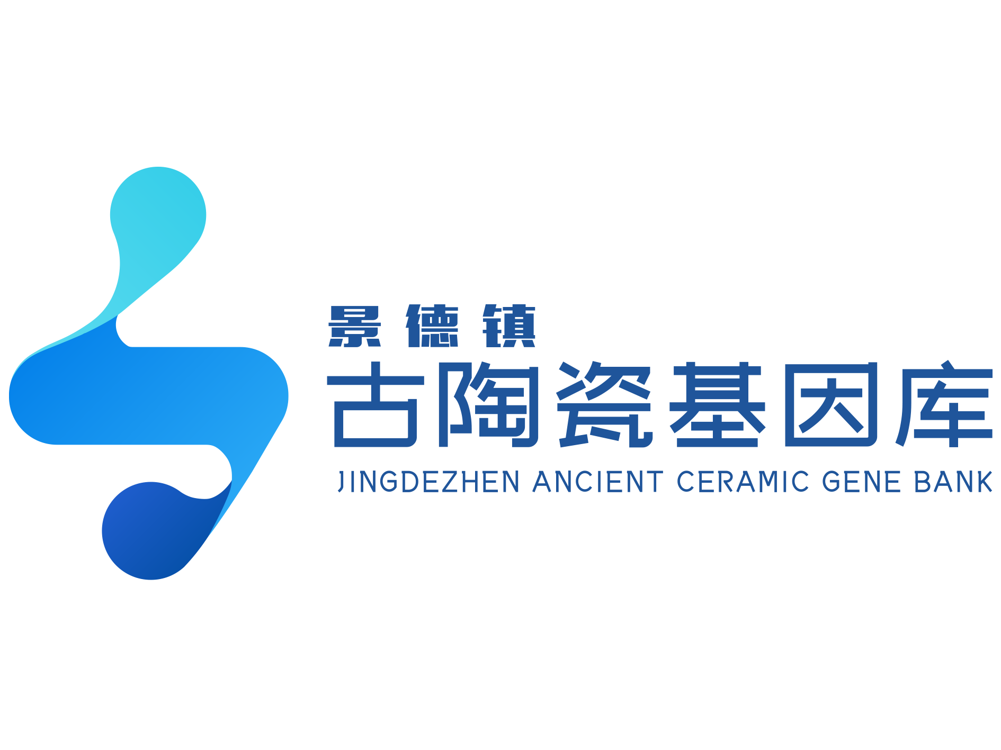

Ducktor Sui — IP Profile

I. Identity File
Field | Details
Name | Ducktor Sui (known as 岁岁鸭 in Chinese, pronounced Suisui Ya)
Official Title | Ming Dynasty Chenghua Period Plain Tricolour Duck-Shaped Incense Burner
Date of Origin | Chenghua Reign, Ming Dynasty (1465–1487)
Height | 25.3 cm overall
Birthplace | Imperial Kiln Factory, Jingdezhen
Signature Traits | • Distinctive floral eyes • Ginkgo-shaped wing feathers • Tender yellow webbed feet • Begonia-latticed pedestal
Identity Tags | Top imperial kiln icon; definitive example of Chenghua plain tricolour ware
Life Story | Smashed and buried underground for over 500 years; excavated in 1987 from the Zhushan Imperial Kiln site; restored to wholeness — only 6 fully restored examples worldwide

II. Physical Features & Character
Body Part | Description
Face & Expression | Signature round floral eyes with cobalt-blue pupils; head perpetually tilted skyward, beak open with tongue out
Wings & Plumage | Wing feathers layered delicately like spreading ginkgo leaves; coated in peacock-green glaze
Colour Palette | Yellow, green, and purple dominate. "Sancai" (tricolour) means no red — the "rich" colour is absent, yet the palette is surprisingly layered: two yellows (earthy and tender), three greens (ink-dark, peacock, grass), plus aubergine-skin purple. The blue fleck in the eye is cobalt blue applied underglaze.
Base & Feet | Stands on a square pedestal with begonia-style latticed cutouts on all four sides; splayed feet connect to the duck's webbed feet; underside bears a six-character square mark in cobalt blue: "Made in the Ming Dynasty Chenghua Reign"
Functional Feature | Body splits into upper and lower halves (lid and incense chamber joined at collars). The neck is hollow and connects to the open beak. Six concealed holes at the collar's rim allow air to enter the body cavity and flow up through the beak — when incense is lit inside, smoke drifts naturally out through the open mouth.

III. Family Tree — The Six Reborn Ducks
No. | Artefact | Distinguishing Feature
1 | 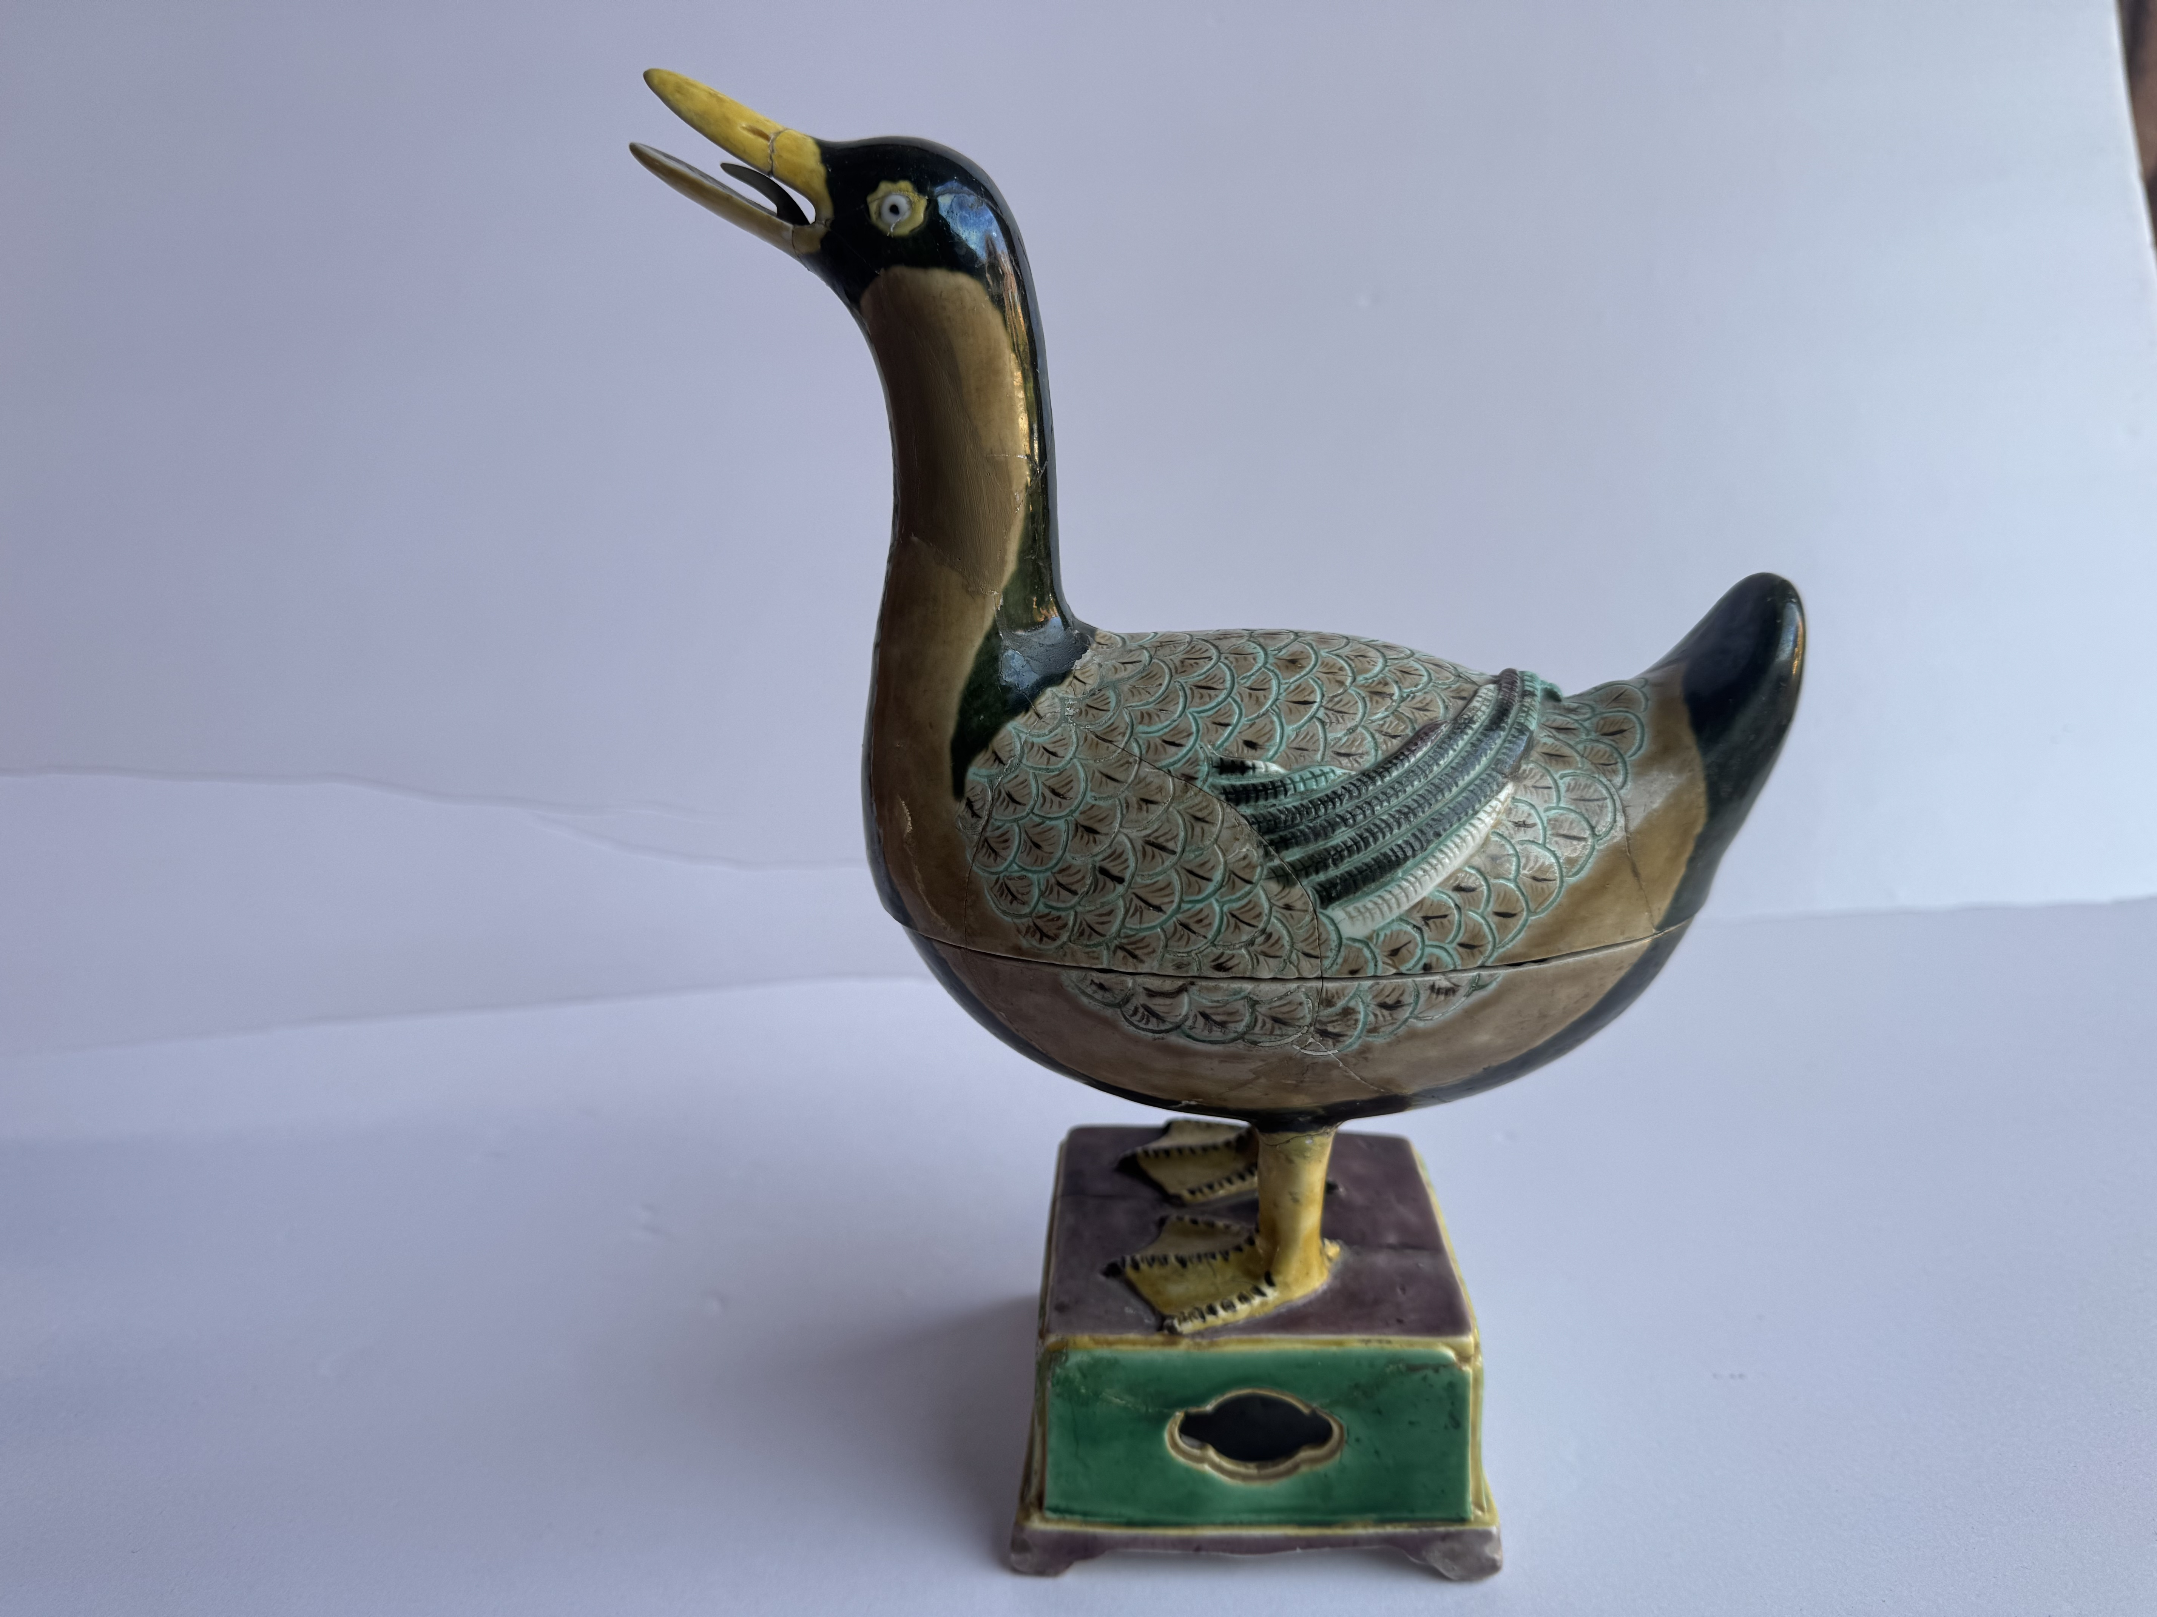 | Most completely reassembled; no missing fragments
2 | 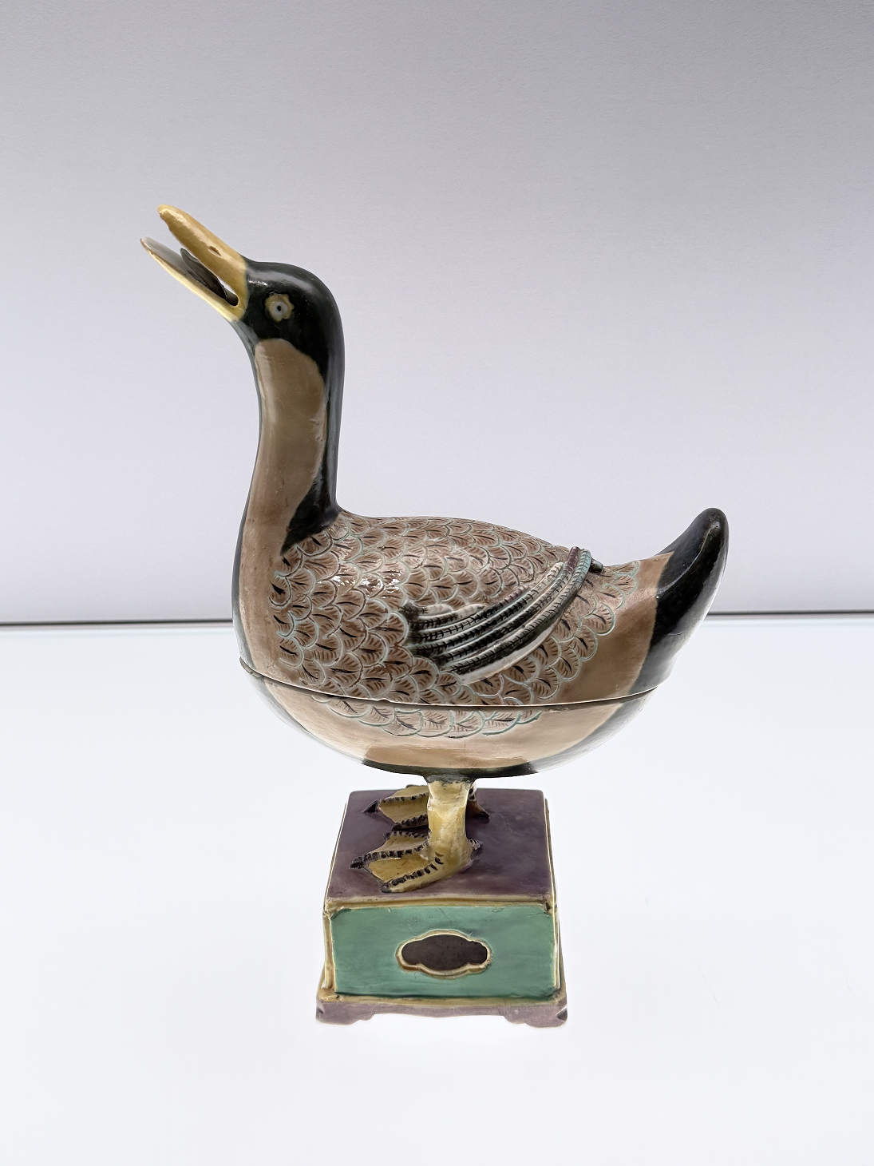 | Long-term resident at the Shanghai Museum; head held at the highest angle
3 |  | Restored at the Palace Museum — the only one to have "entered the imperial palace"; also exhibited at the Beijing Agricultural Exhibition Hall; spent 4 years in Beijing
4 | 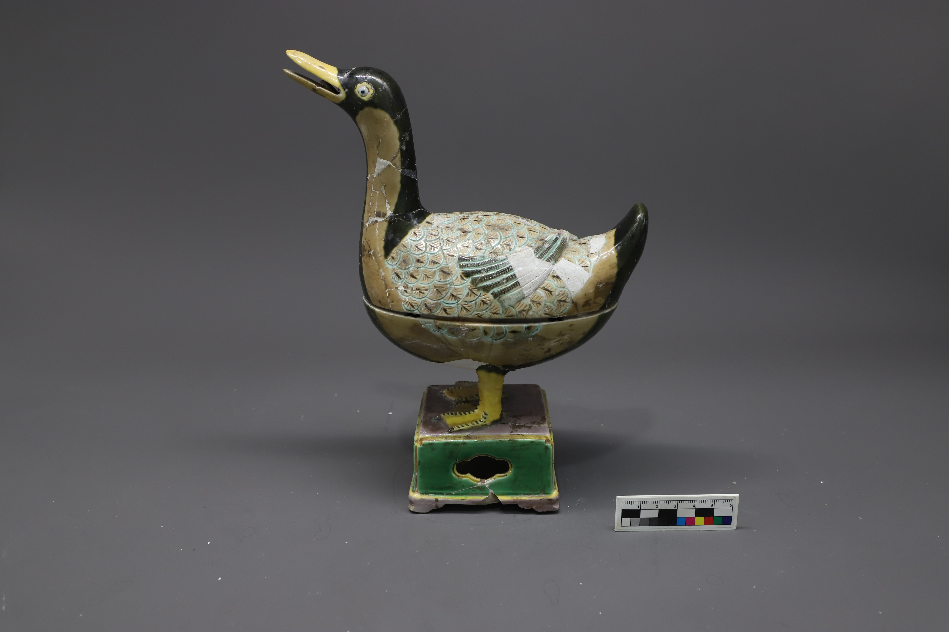 | Most shards of any: 68 fragments
5 | 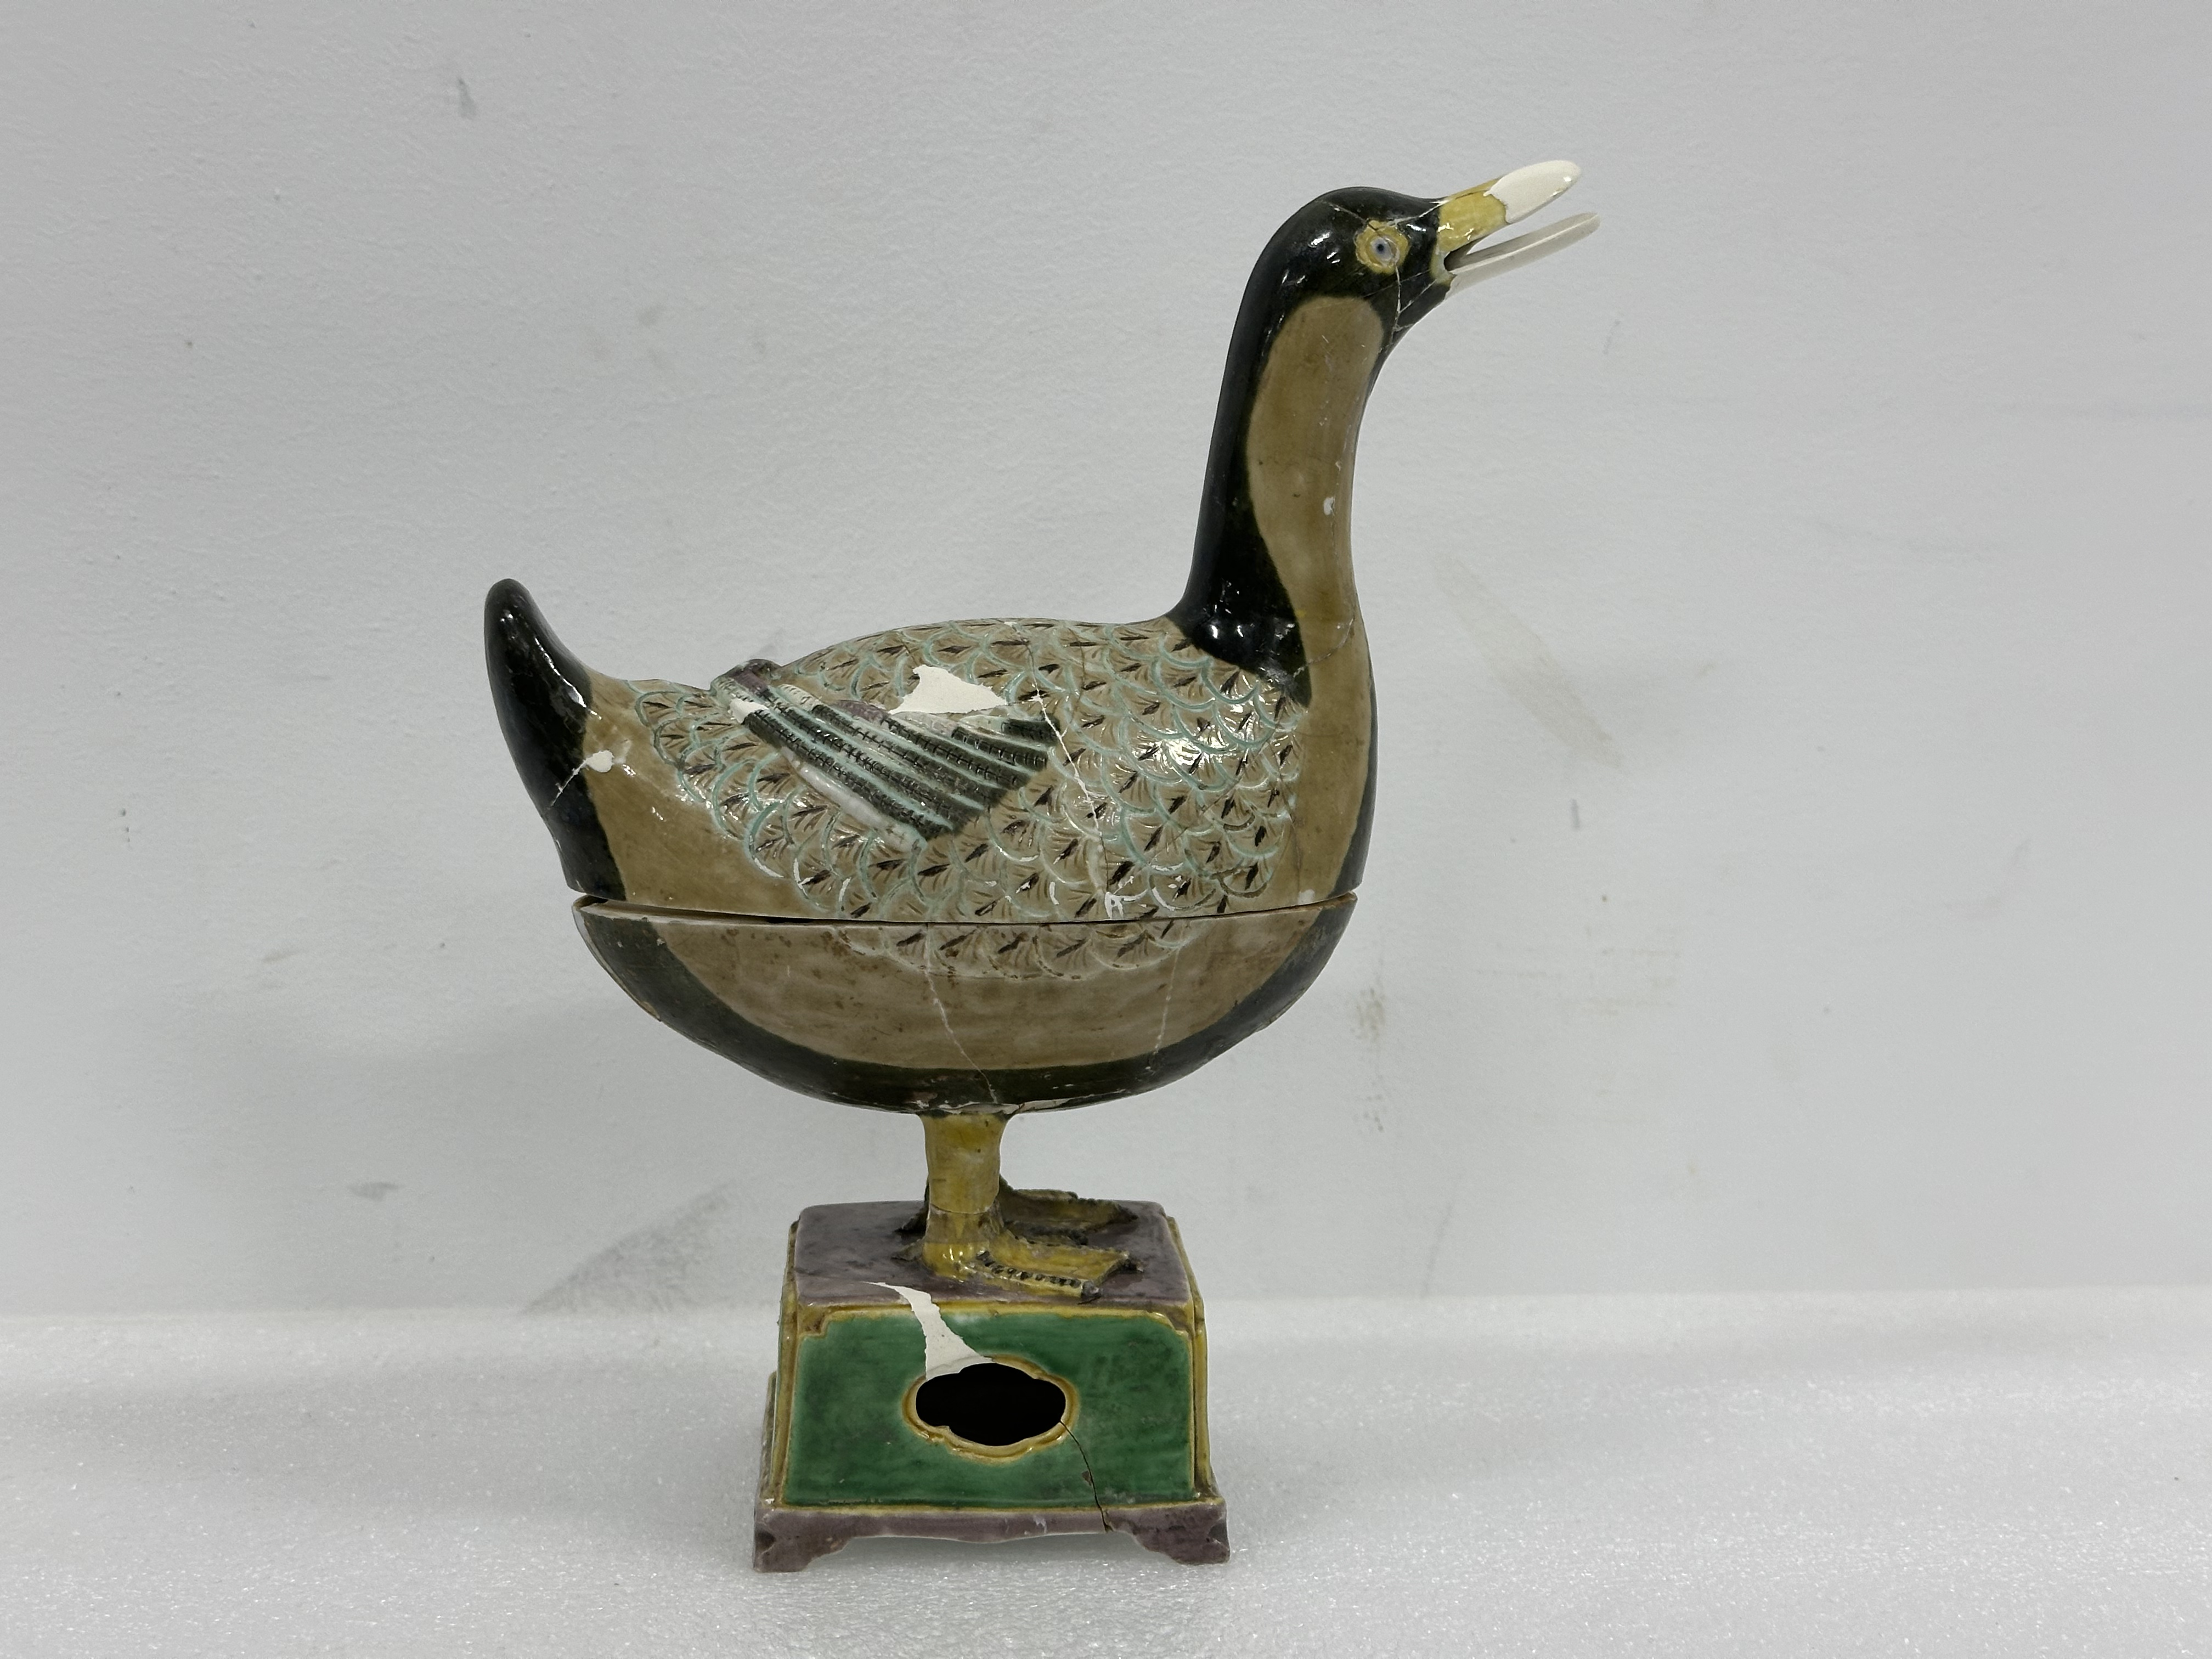 | Beak incomplete
6 | 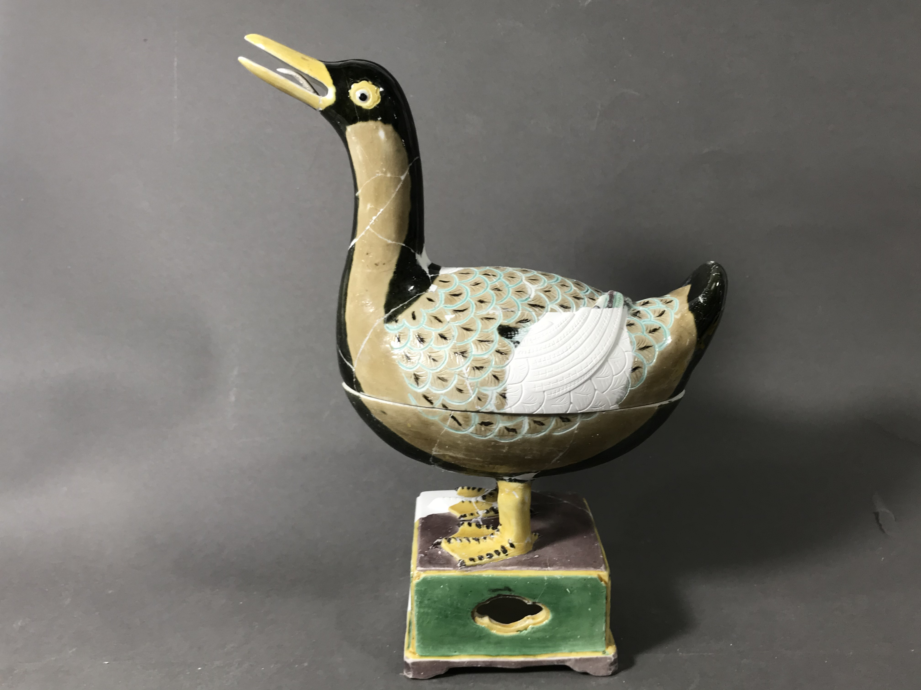 | Wing incomplete

IV. Gene Data
Data Type | Content
Colour Chart | 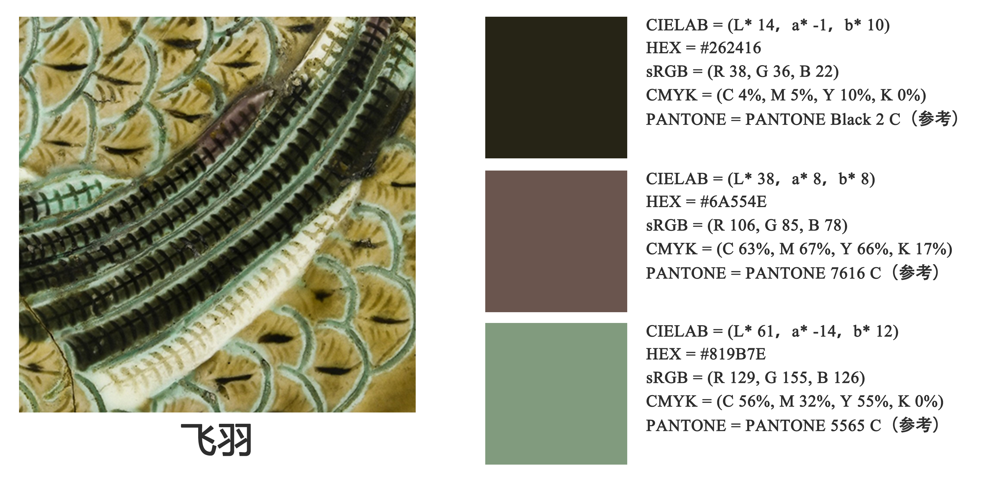  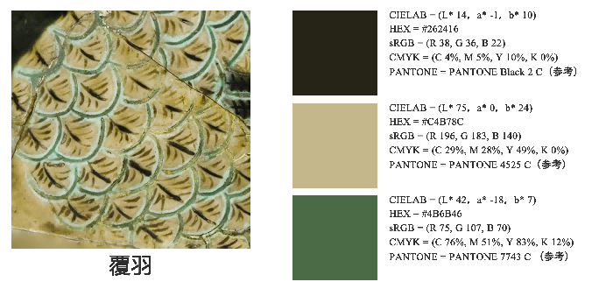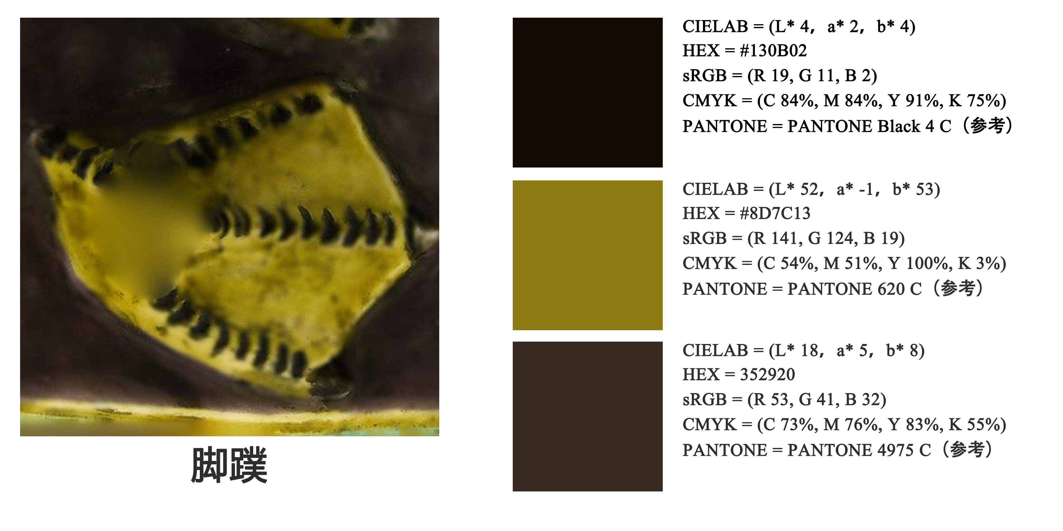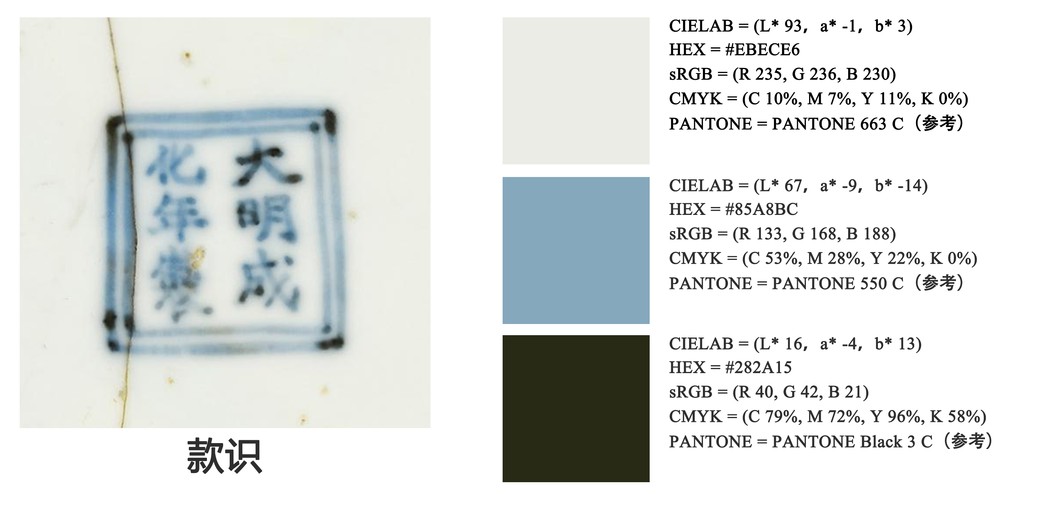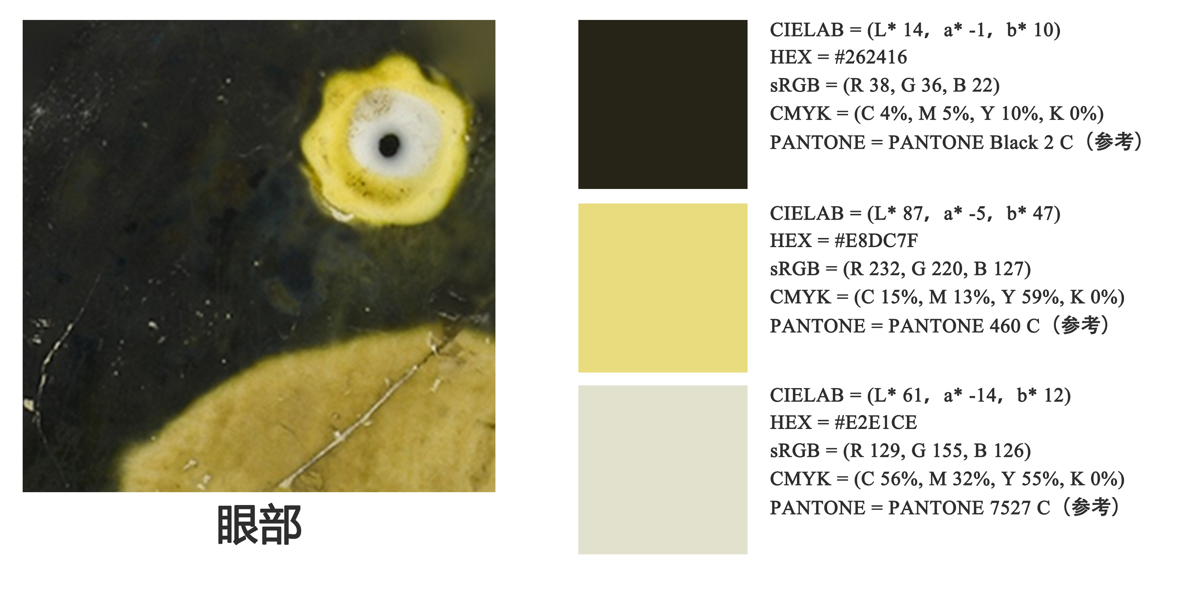
Stereo Microscopy | 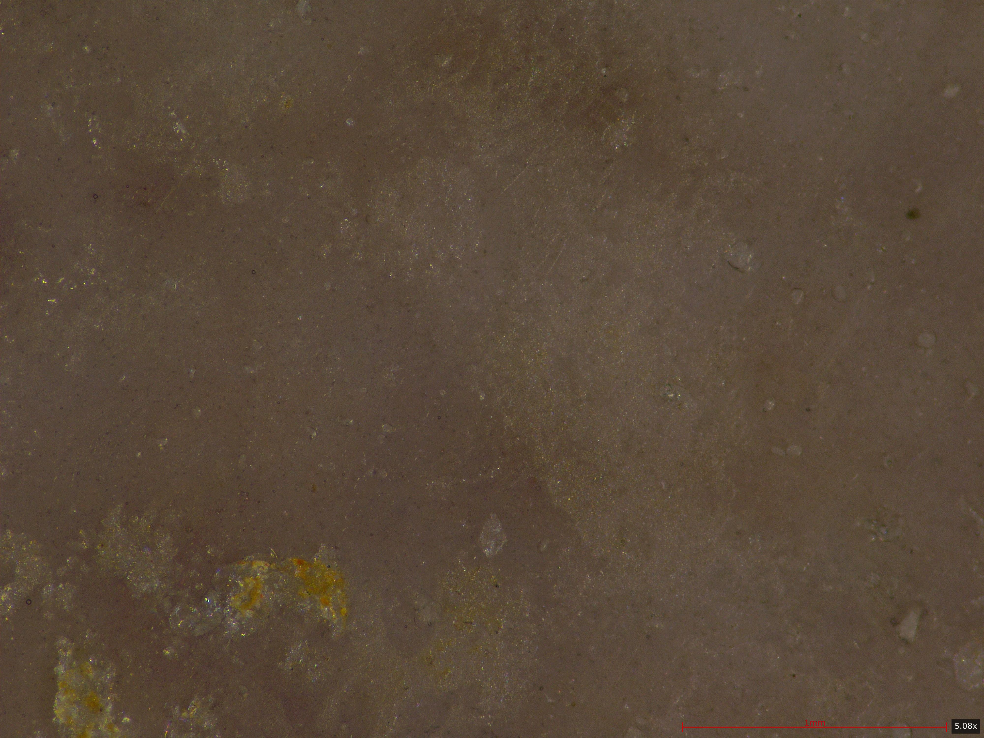  M-Y1501 - Microstructure - Pigment: Purple - Shard Specimen - 50x |  | 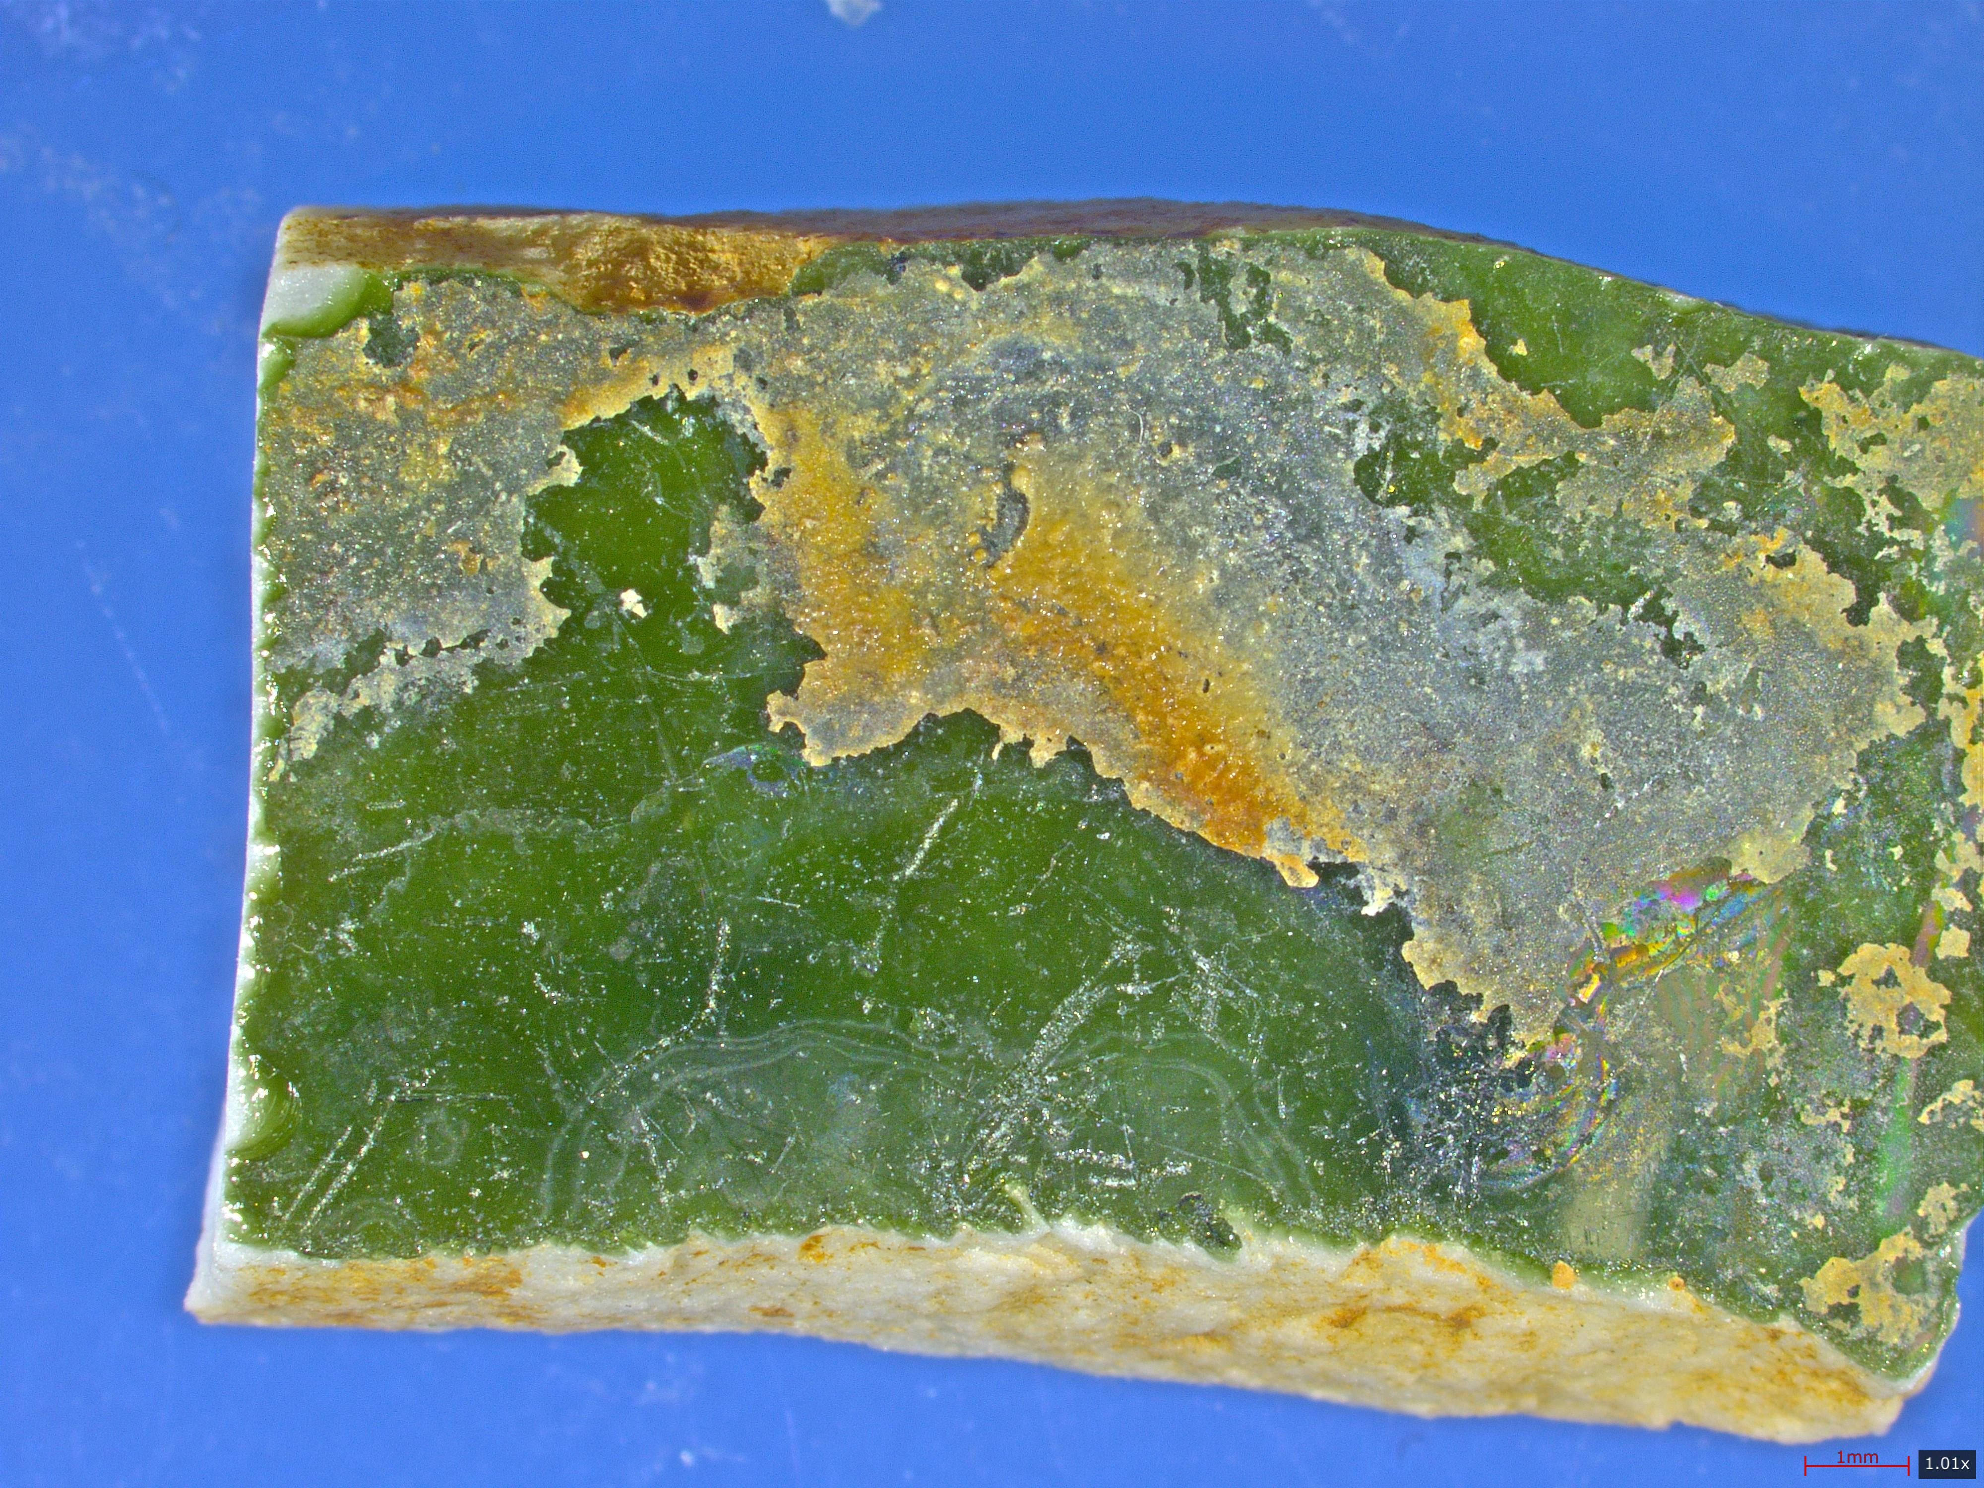  M-Y1502 — Microstructure — Pigment: Turquoise  Green - Shard Specimen - 10x
Stereo Microscopy | 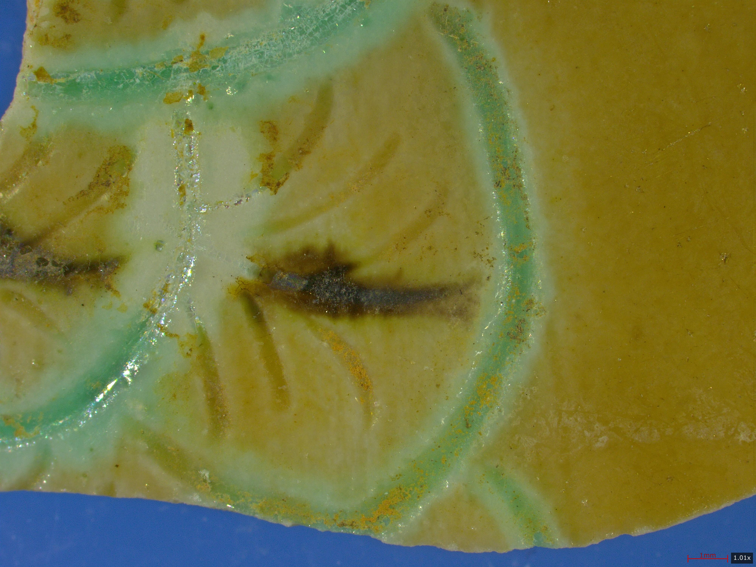  M-Y1504 - Microstructure - Overview - Shard  Specimen - 10x |  | 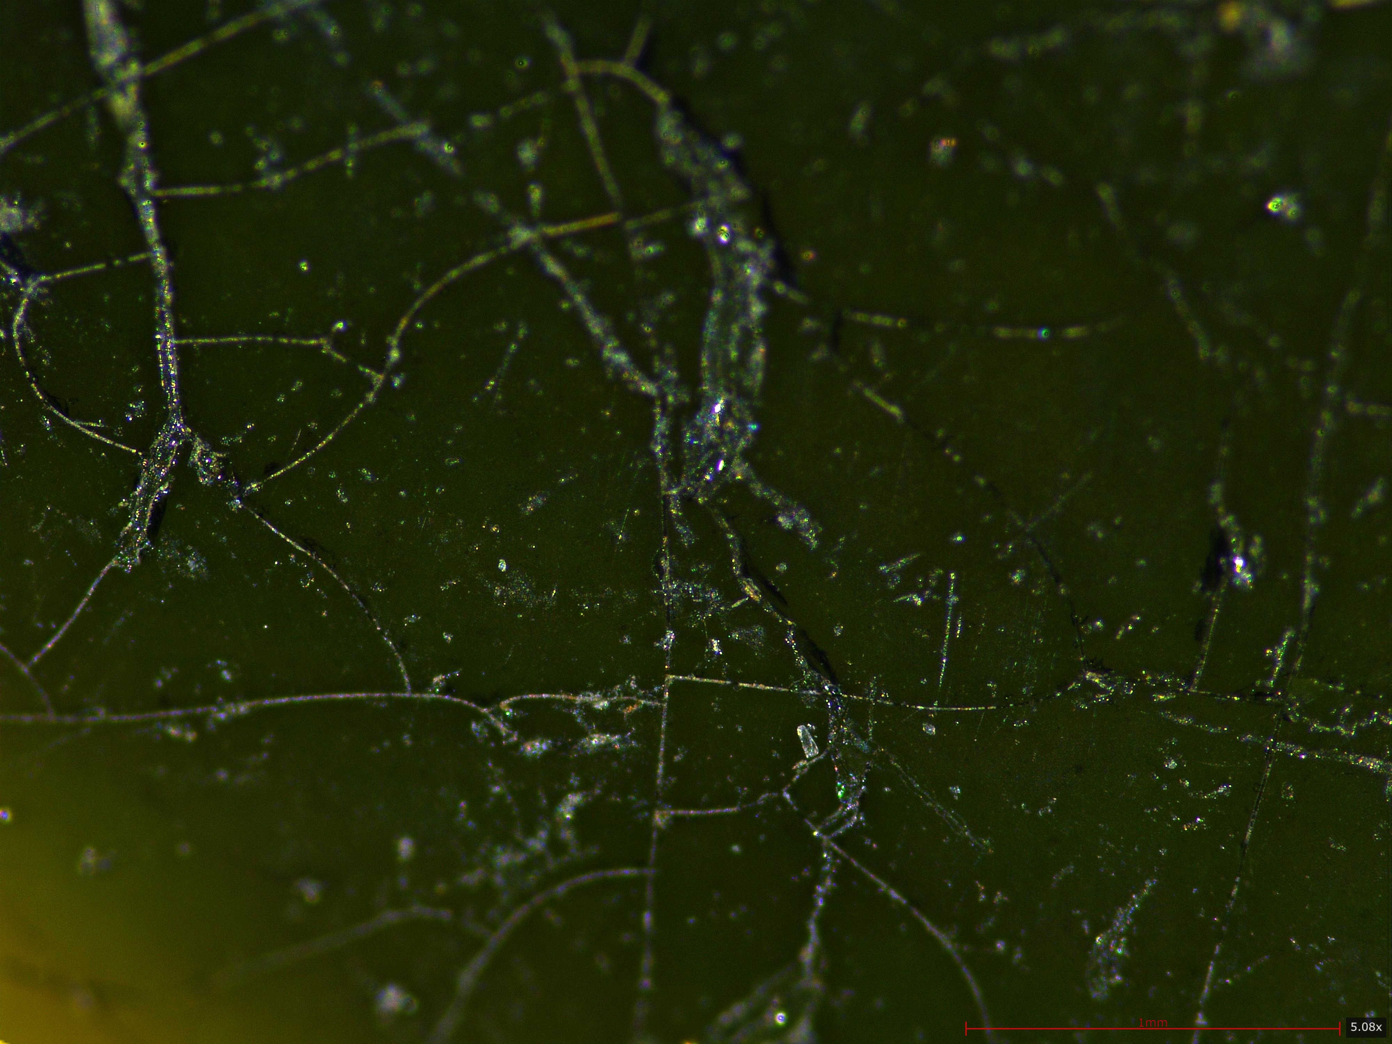  M-Y1509 - Microstructure - Pigment: Ink Green  - Shard Specimen - 50x
 | 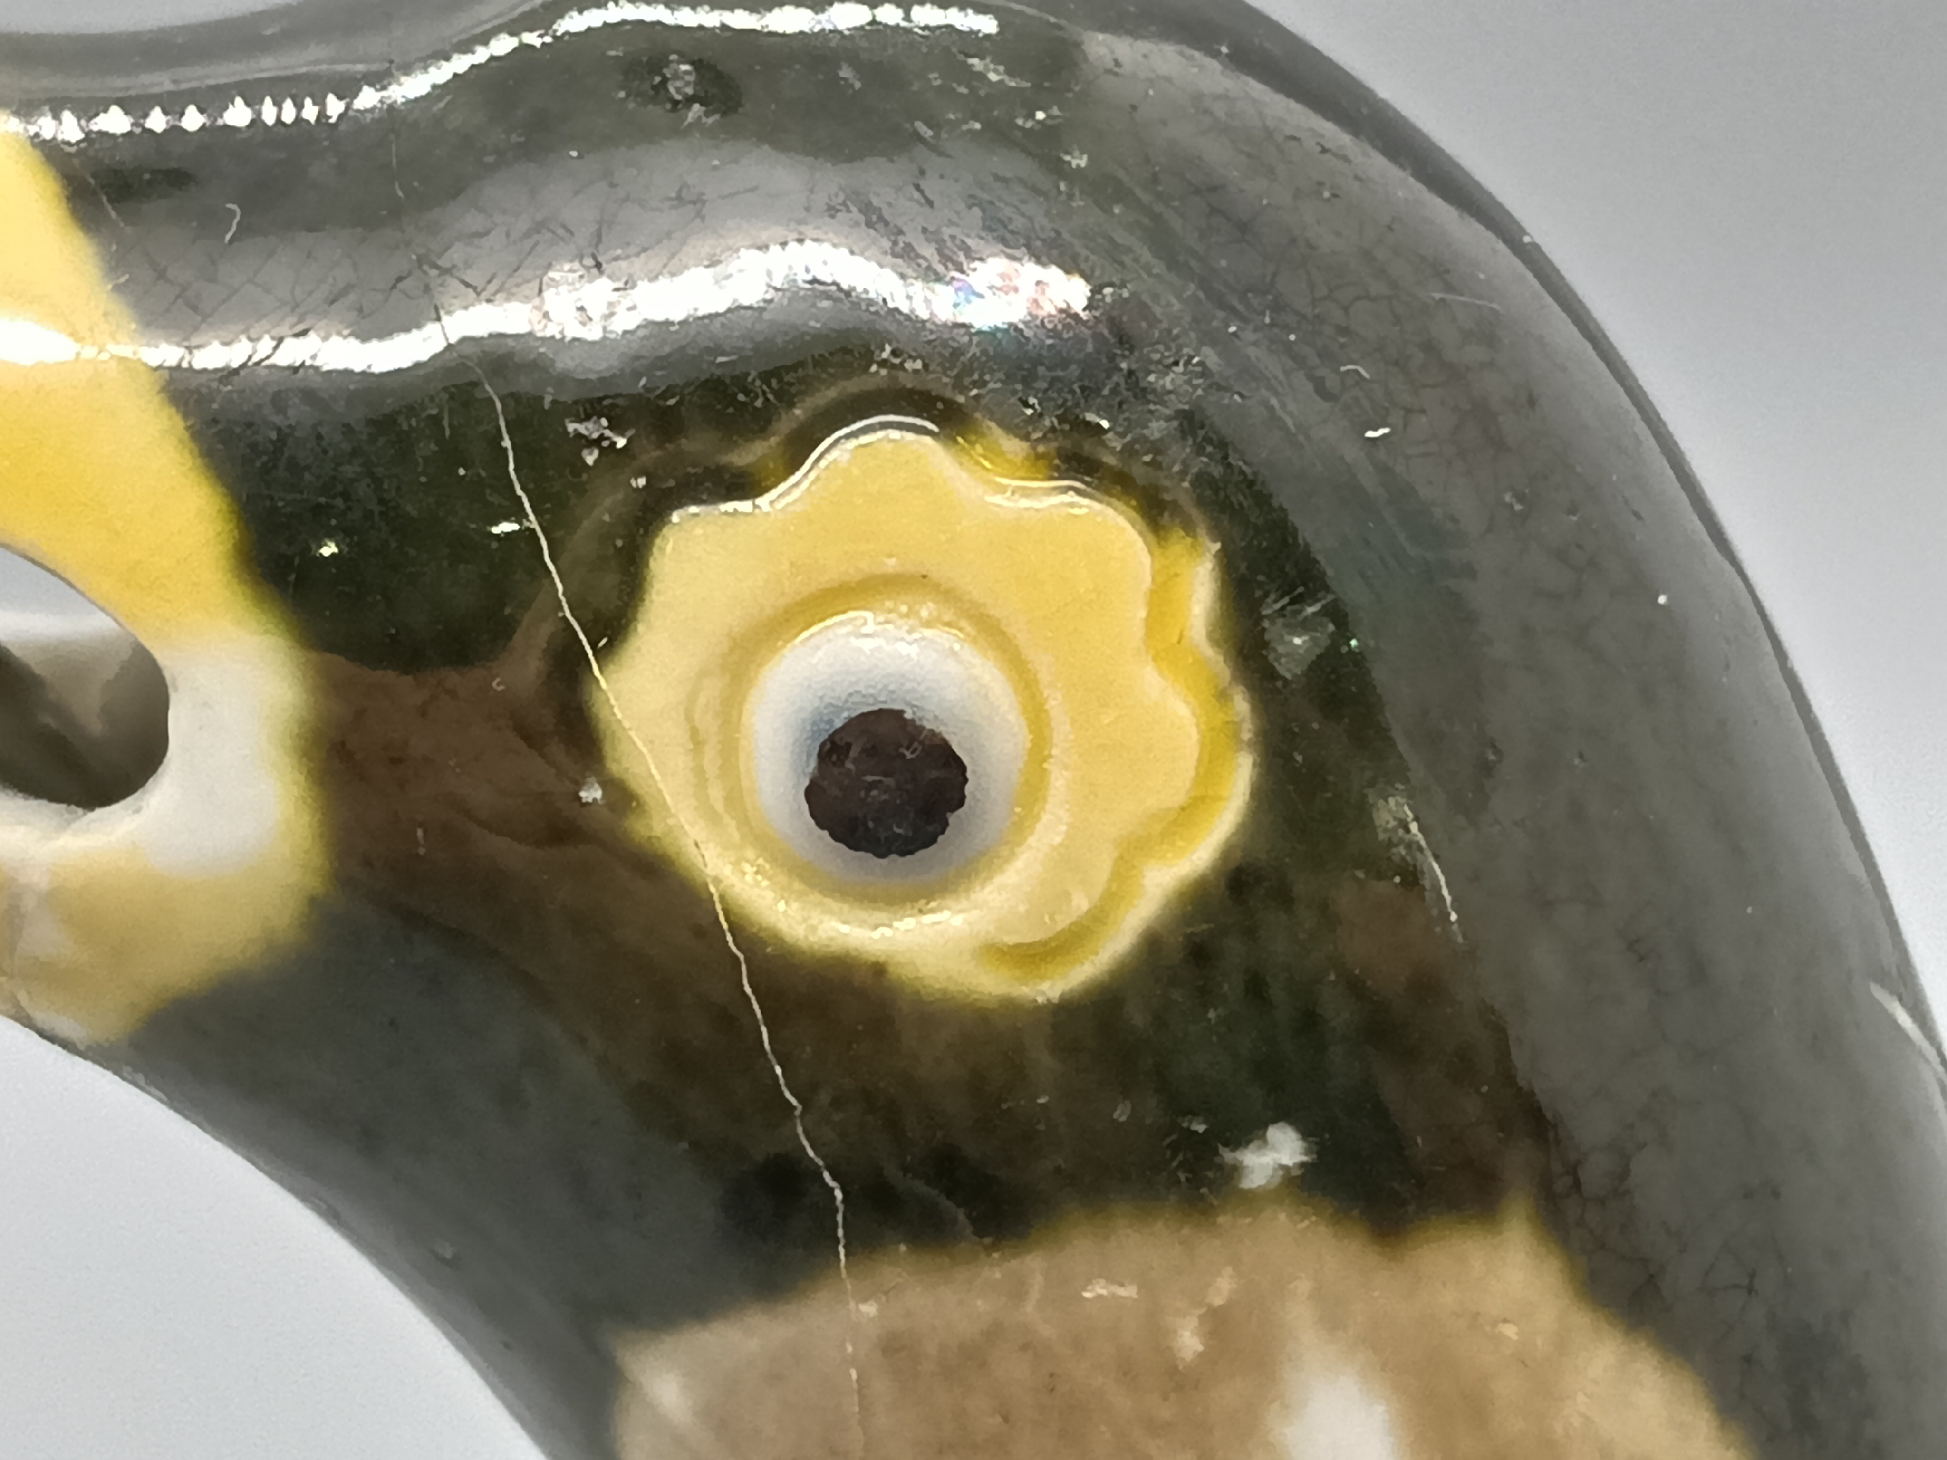 | 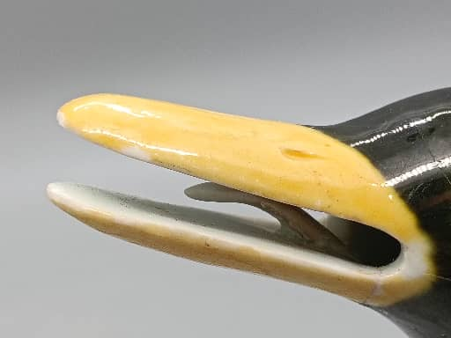 |  |  | 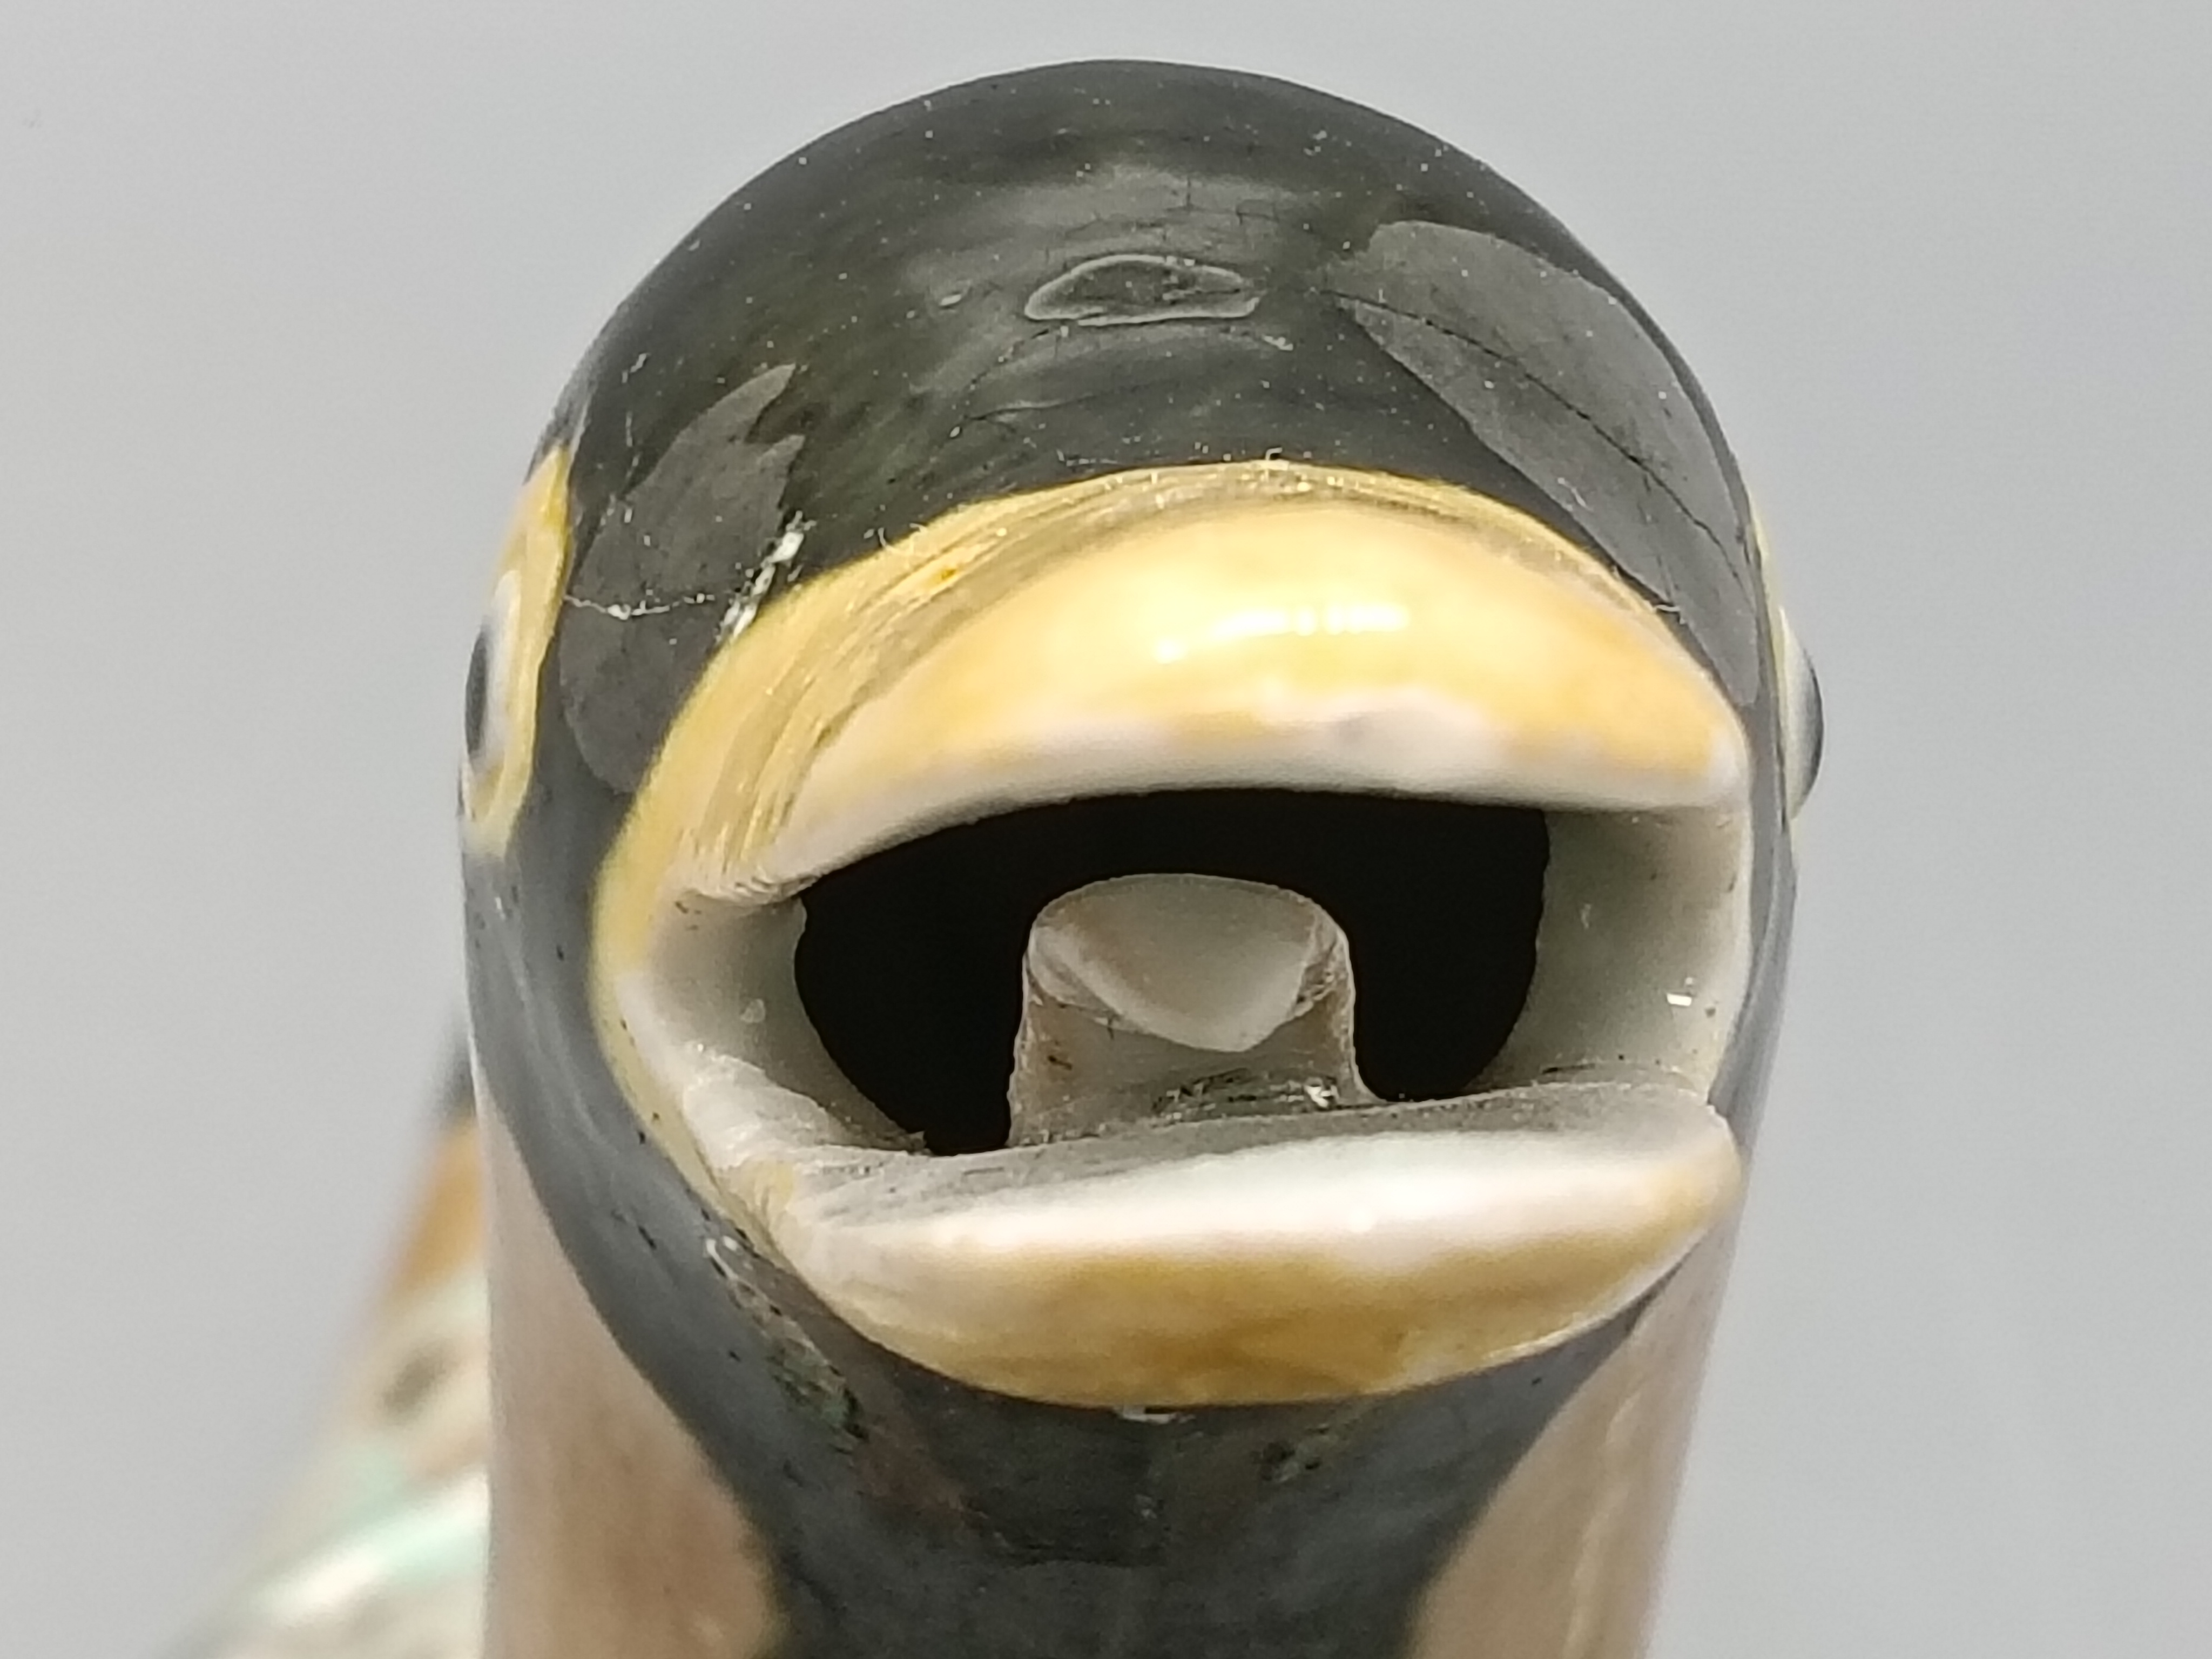
 | 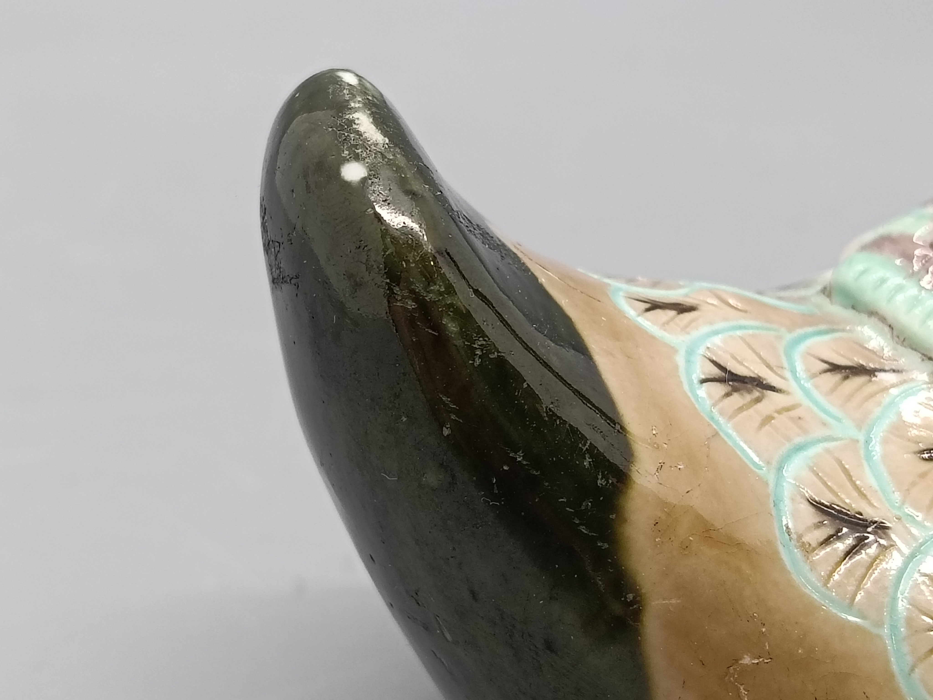 | 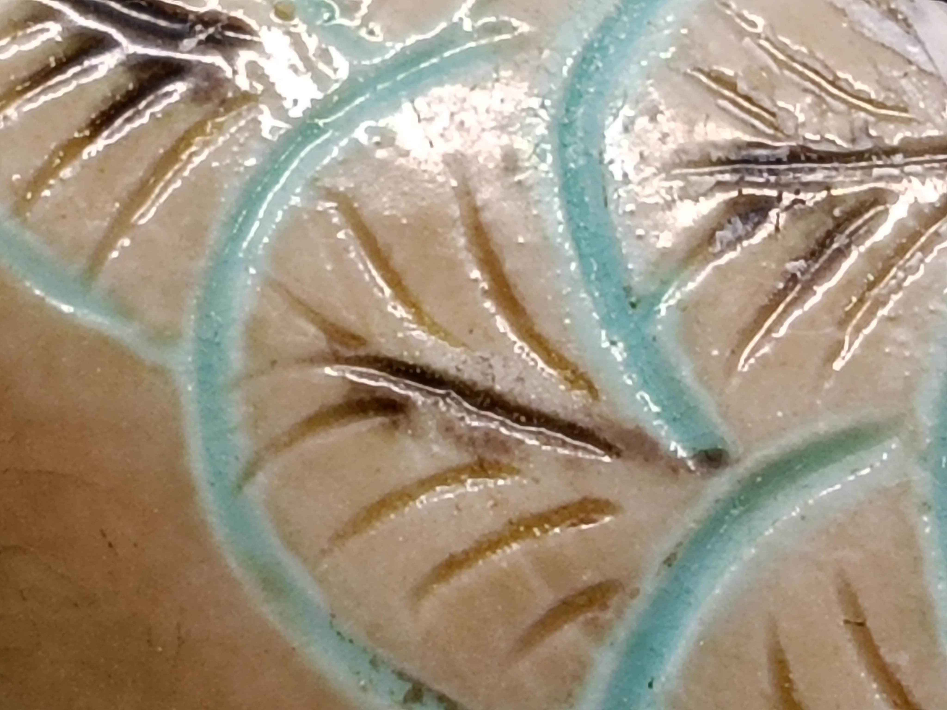 |  |  | 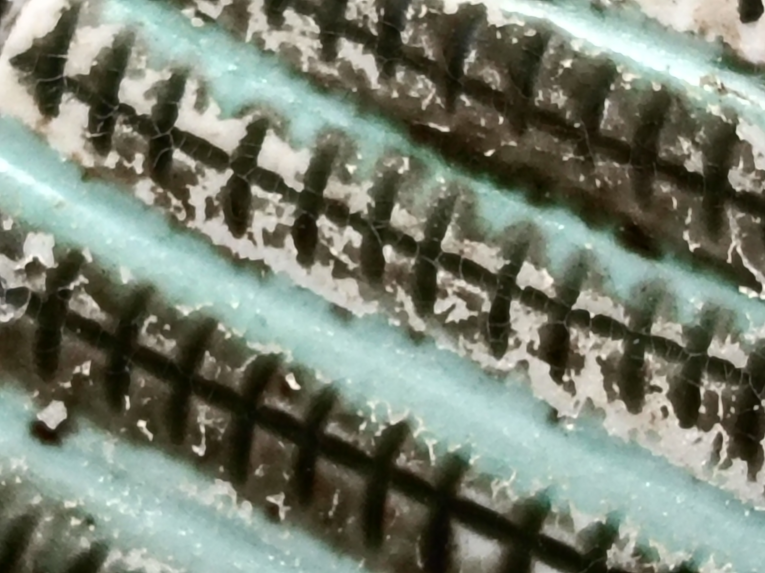
 | 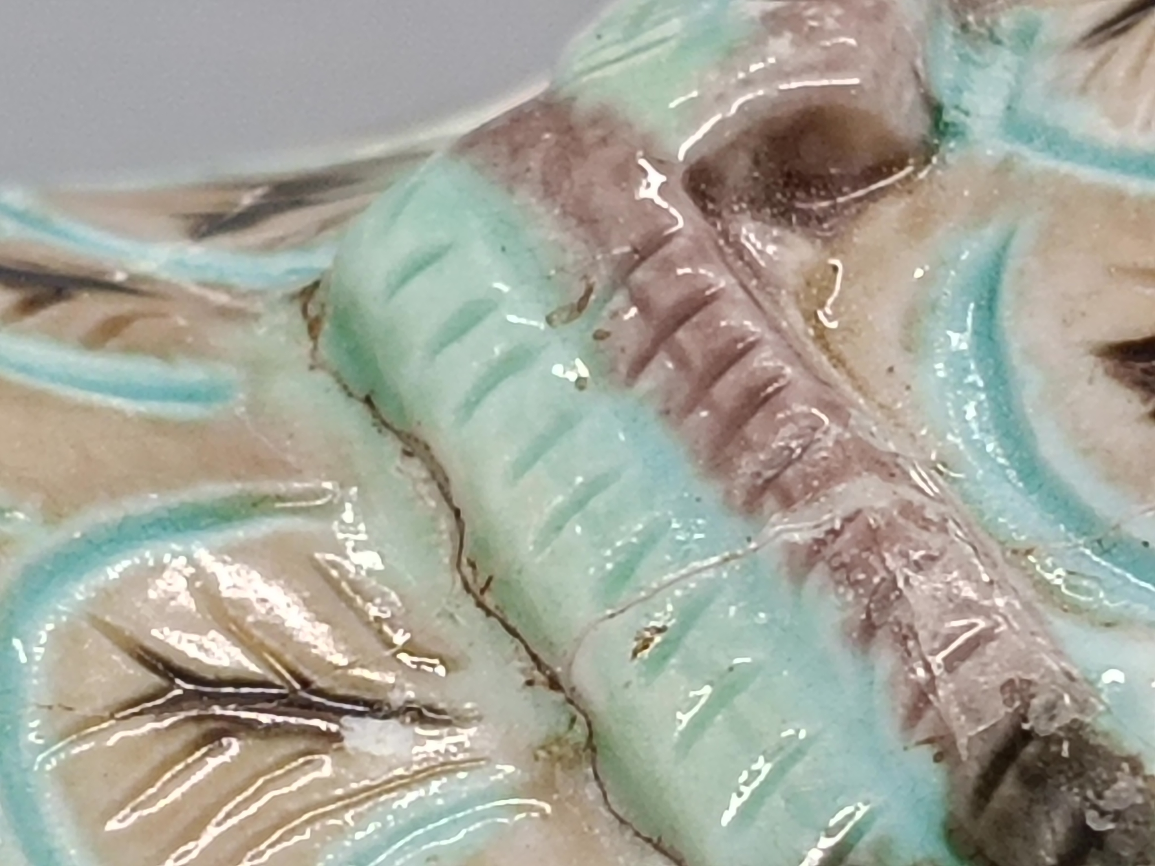 | 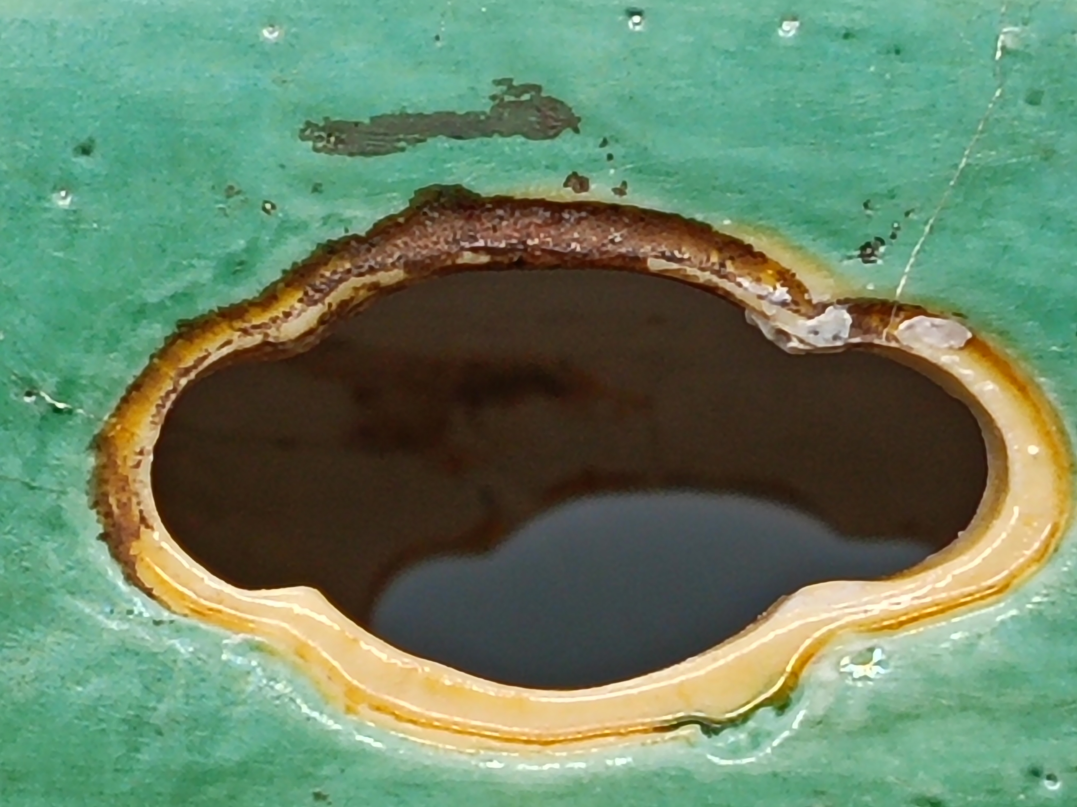 |  |  | 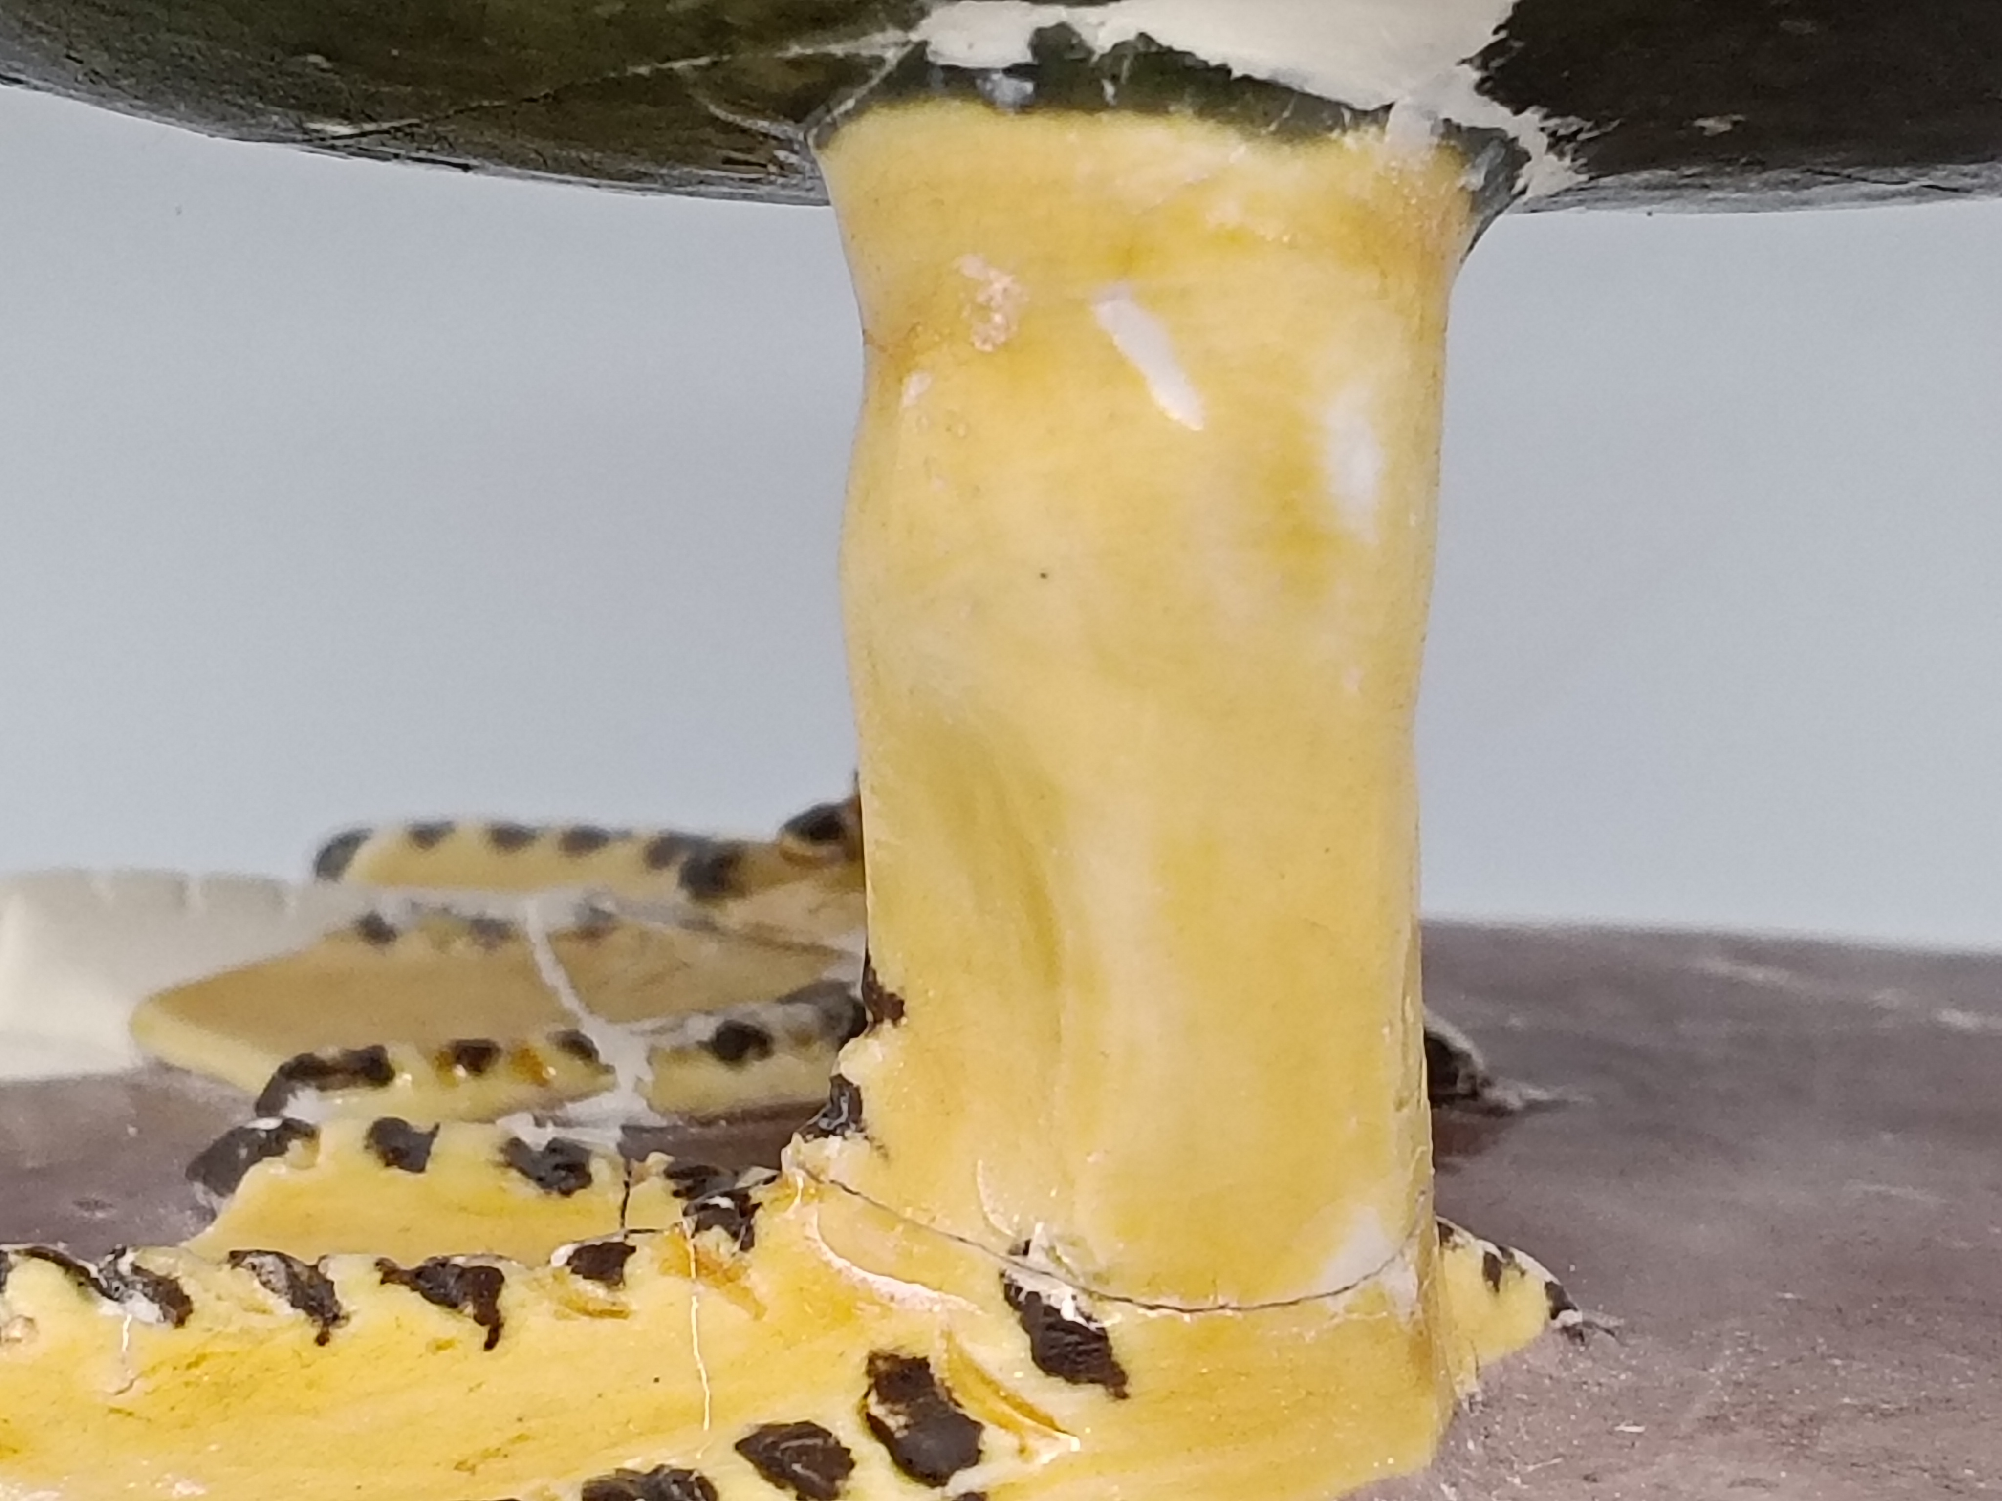
Raman Report | 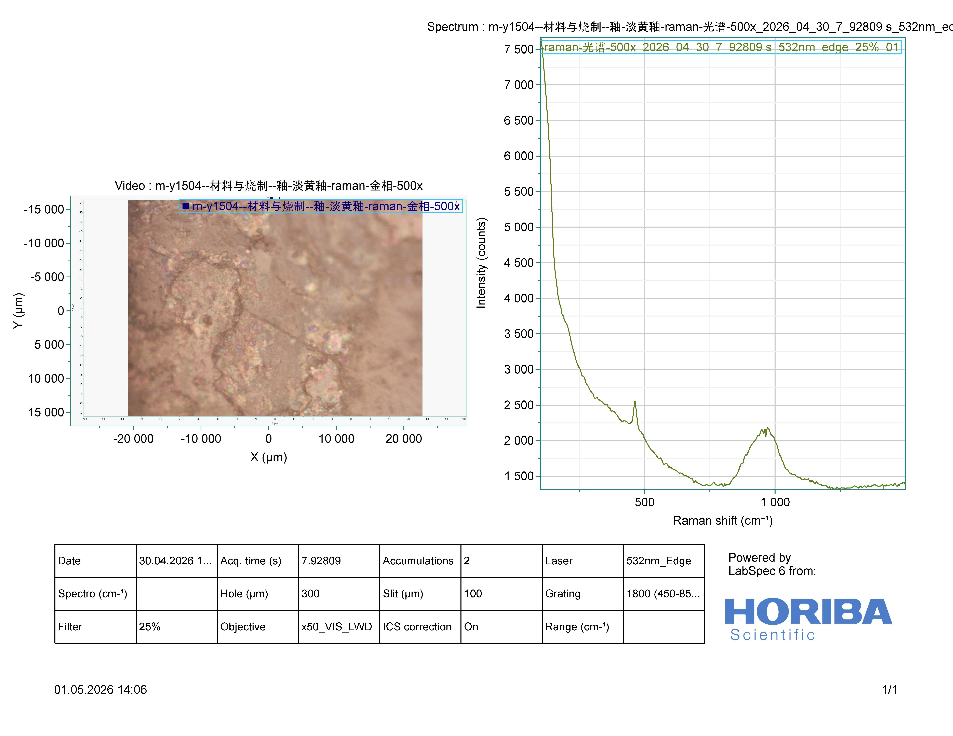  Light yellow glaze 500× |  |  | 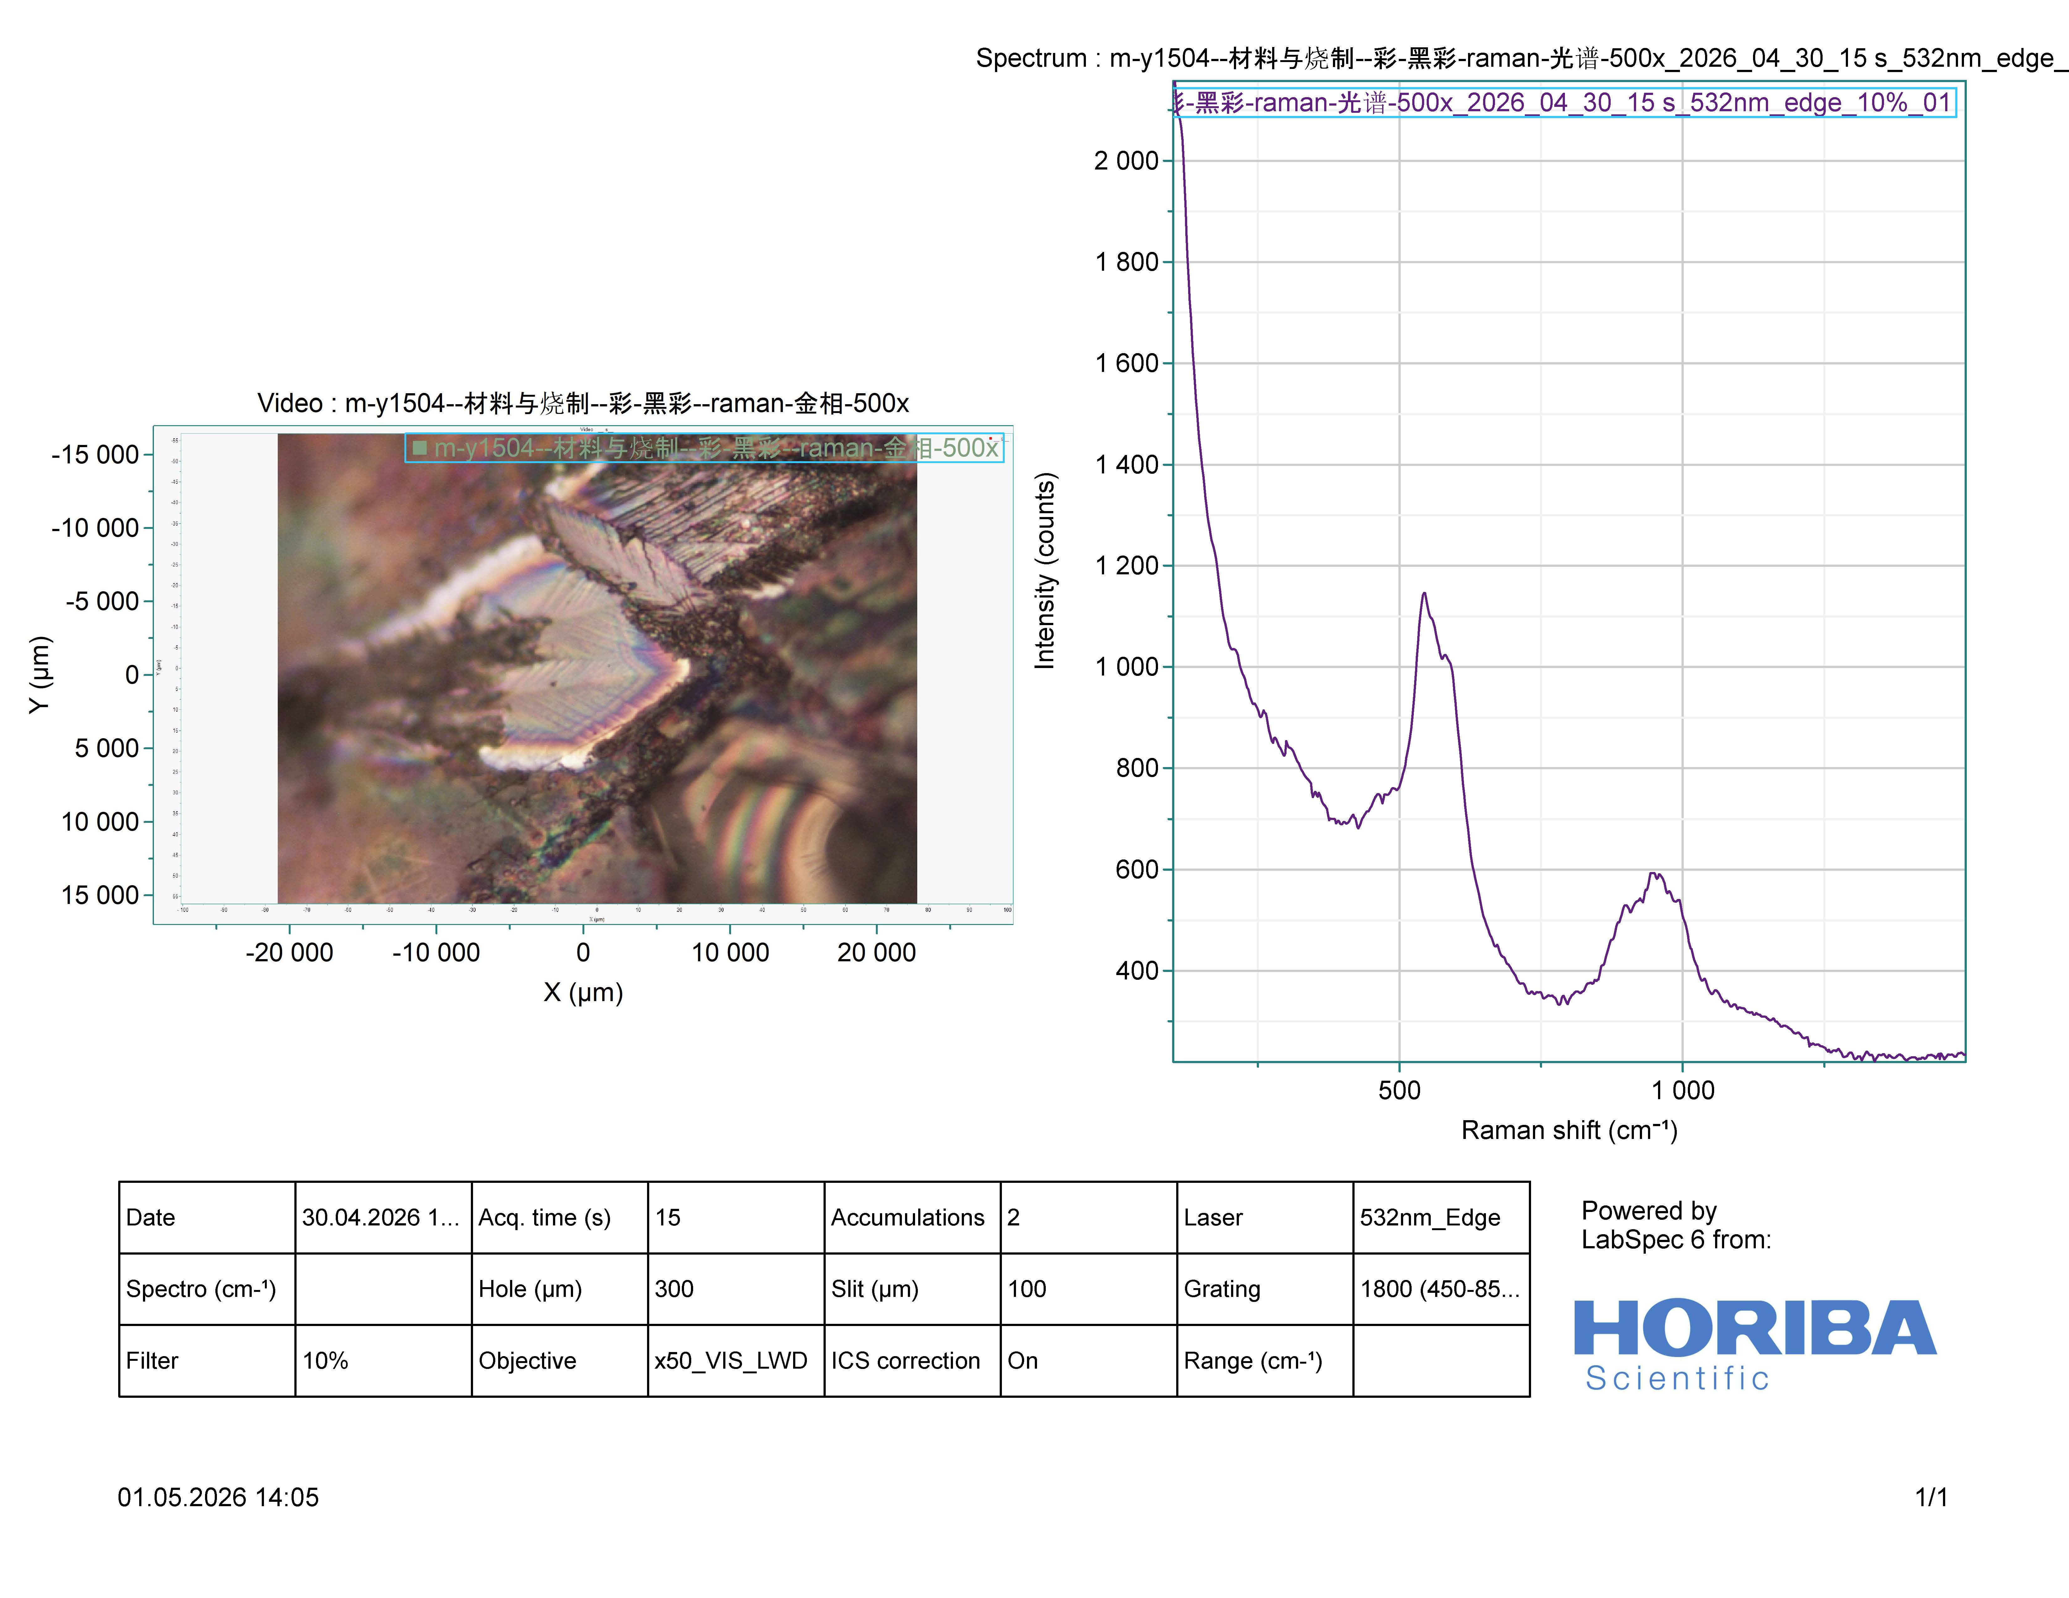  Black pigment 500×
Raman Report | 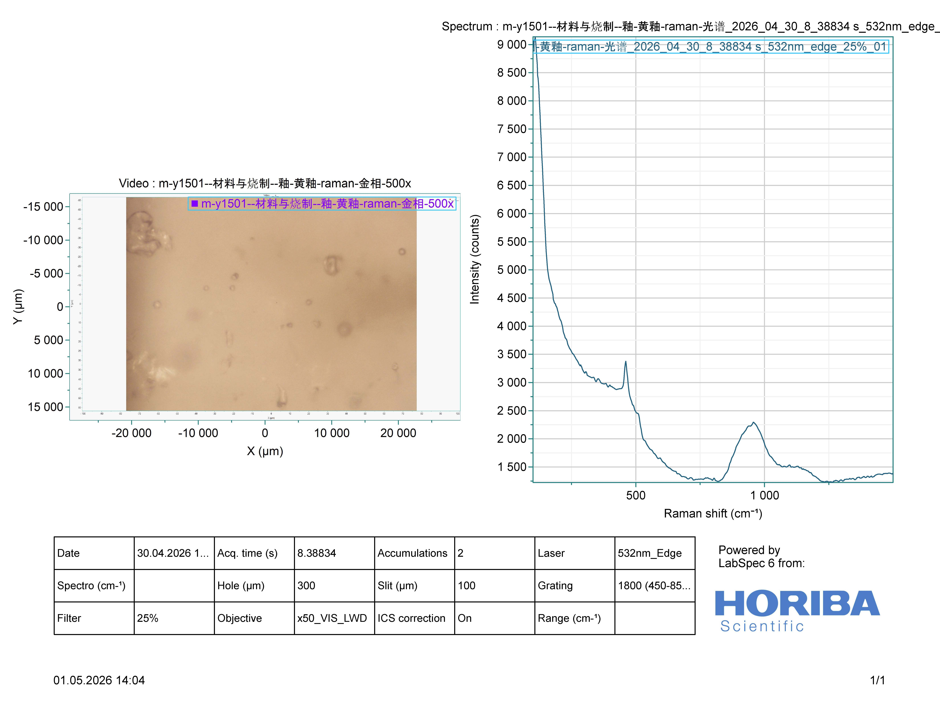  Yellow glaze 500× |  |  | 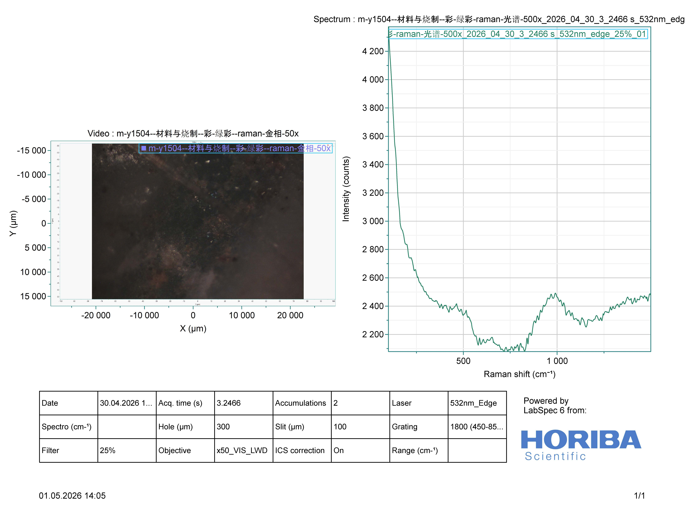Green pigment 500×
XRF | 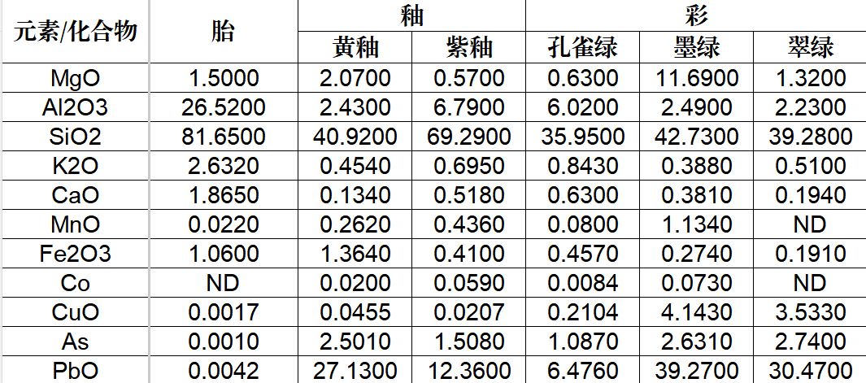
ISO Standard Data — Body | Colour: white body, CIELAB L: 87.2, a: 0.3, b: 3.1  Thickness: thin, 2.9 mm  Weight: light, 710 g  Density: compact, 2.30–2.38 kg/m³  Hardness: hard, Mohs 6–7  Water absorption: low, 0.1%–0.3%  Translucency: medium–high, 15%–35%
ISO Standard Data — Body–Glaze Interface | Bond type: chemical  Condition: intact  Intermediate  layer: see microscopy images
ISO Standard Data — Reign Mark | Language: Chinese  Content: reign mark  Script: regular script (kaishu)  Layout: vertical, two columns  Border: double frame  Method: painted  Colour: cobalt blue  Position: exterior base
ISO Standard Data — Decoration | Head: incised, polychrome glaze, animal motif  Body: incised + carved, polychrome glaze, animal motif  Feet: carved, polychrome glaze, animal motif  Pedestal: carved, polychrome glaze, auxiliary pattern
Further Design Assets | Jingdezhen Ancient Ceramics Gene Bank:  http://cgb.jdzyybwy.com:9990/duck    (mobile access)

V. Characters

Six Ducks, Six Personalities:
This competition features six duck-shaped incense burners excavated from the site. Designers are invited to give each duck its own distinct IP identity — different personalities, roles, and stories — forming a recognizable "Ducktor Sui Family." The following are six suggested directions (for inspiration only; free interpretation encouraged). Three names are confirmed; three remain open:

Name | Personality Suggestion
Ducktor Sui (known as岁岁鸭 in Chinese)  Homophone note: Same pronunciation as below. 岁岁 stands for year after year, carrying the blessing of peace all year round. | Outwardly proper, inwardly mischievous...
Ducktor Sui (known as碎碎鸭 in Chinese)  Homophone note: Identical pronunciation, different characters. 碎碎 refers to shattered. | Shattered but socially fearless...
Bursting Duck  (known as爆棚鸭 in Chinese) | Domineering yet warm-hearted...
(TBD) | Seeking grain, finding benevolence...
(TBD) | Vivid without vulgarity...
(TBD) | Introvert, socially anxious...

These six ducks are entirely yours to define — cold, dopey, mysterious, wild... Each has its own "duck-ality." Together they make quite a show.

Huggy Lion — IP Profile

I. Identity File
Field | Details
Name | Huggy Lion (known as 抱抱狮 in Chinese, pronounced Baobao Shi)
Official Title | Yuan Dynasty Sacrificial Blue Glazed Lion-shaped Lid Knob
Date of Origin | Yuan Dynasty
Dimensions | Surviving height: 9 cm; body width: 3.9 cm
Birthplace | Jingdezhen Kiln
Signature Traits | • Sacrificial blue glaze fired with imported Persian cobalt • Drooping ears, curled tail, endearing form • Double lotus-petal base • Brocade ball held in forepaws
Identity Tags | Rare Yuan-dynasty Sacrificial blue glaze ware; irresistibly charming
Life Story | Born at the Yuan-dynasty Jingdezhen kilns; fired with precious imported Persian cobalt; after centuries of time, still radiates spirit despite partial damage

II. Physical Features & Character
Body Part | Description
Face & Expression | Head tilted playfully to the right; soft drooping ears on either side; lively, spirited eyes brimming with an invitation to play; endearingly dopey yet full of energy
Body & Glaze | Entirely wrapped in a deep night-sky-like sacrificial blue glaze, exclusively with ancient Persian cobalt; glaze surface even and lustrous, casting a soft blue glow in light
Signature Pose | Seated steadily on a double lotus-petal base; forepaws firmly cradling a brocade ball; curled tail tucked neatly at the side — always poised and ready
Innate Gifts | Born with a natural luck buff: the brocade ball is its fortune-gathering vessel, the lotus base its stable ground, and the Sacrificial blue glaze carries an aura of calm protection

III. Gene Data
Data Type | Content
Artefact Photos | 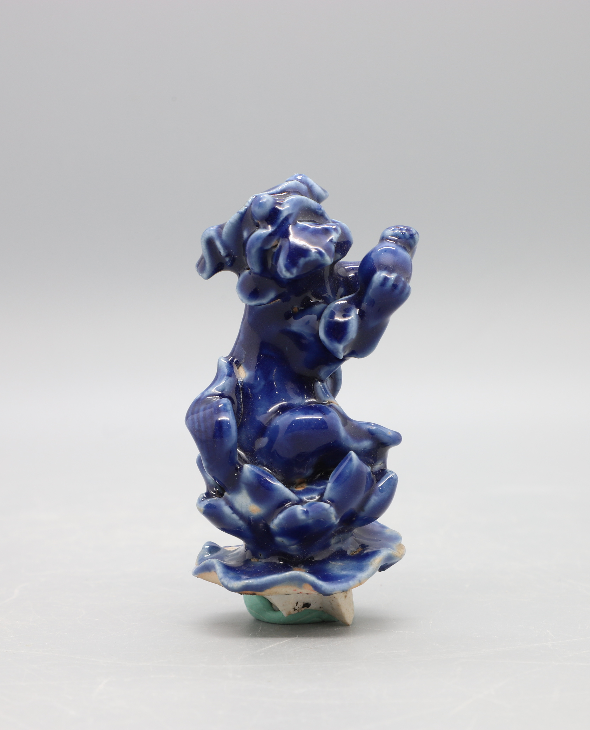 |  | 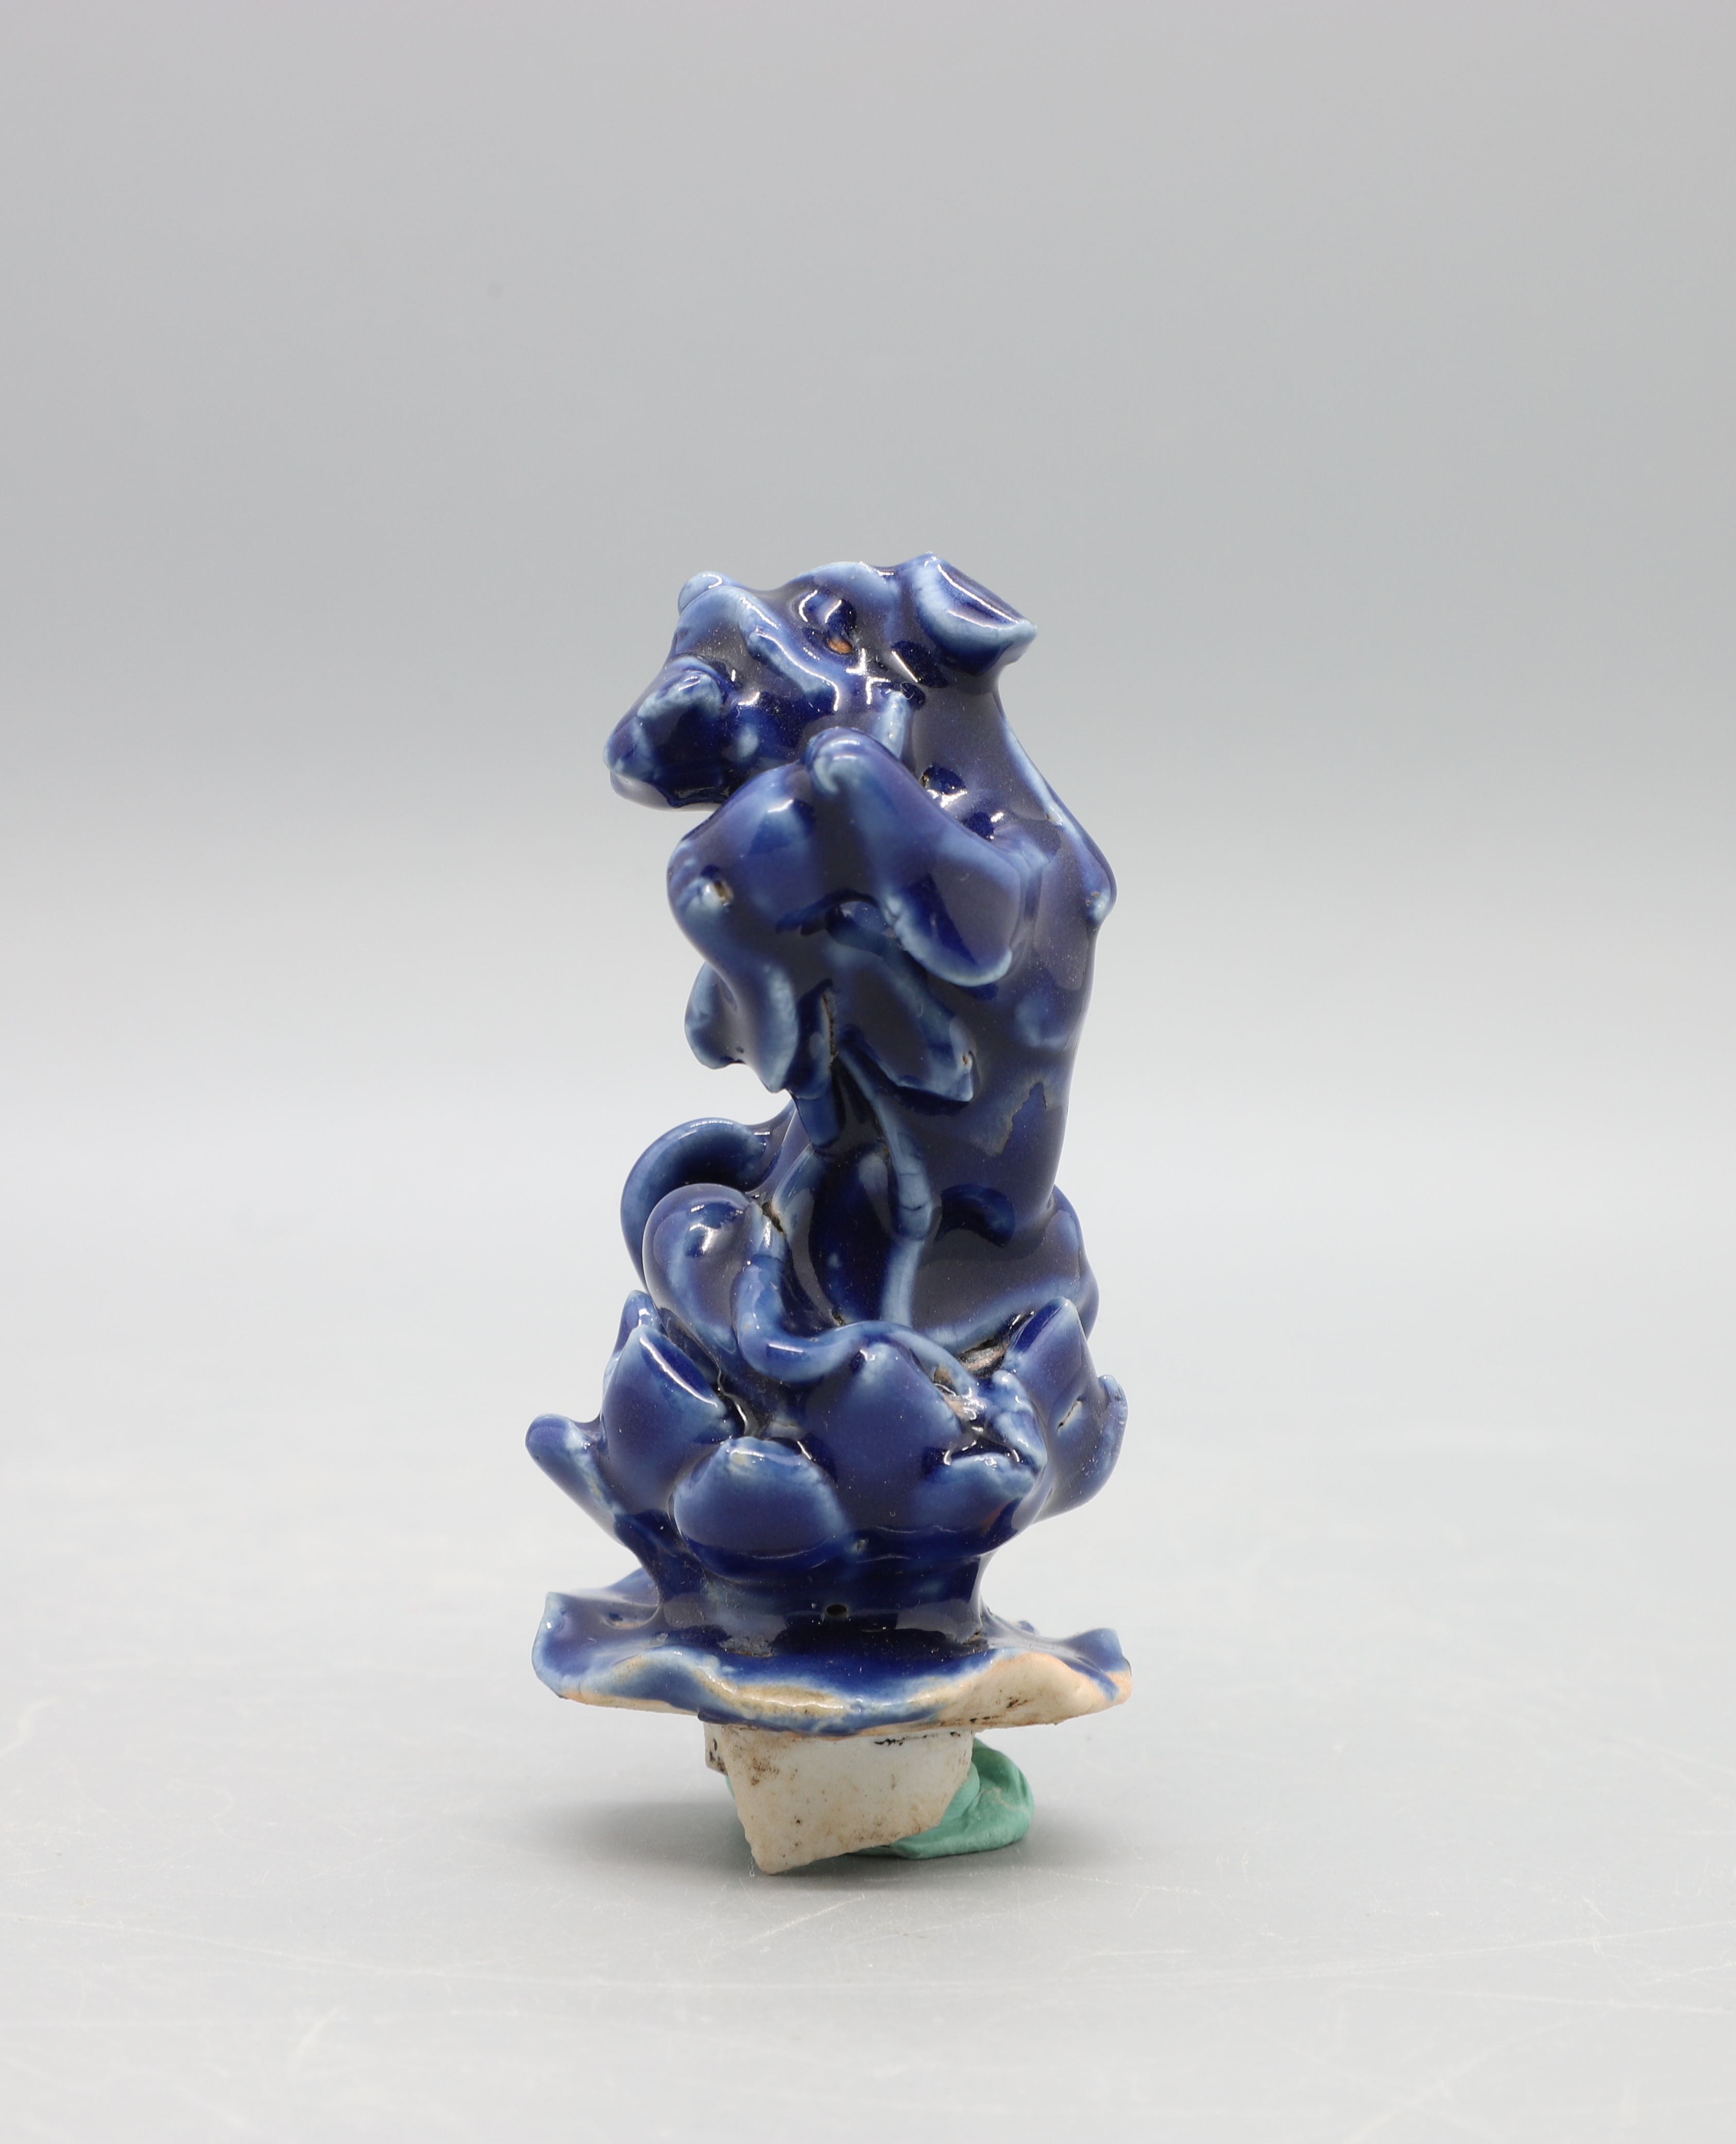 |  |  | 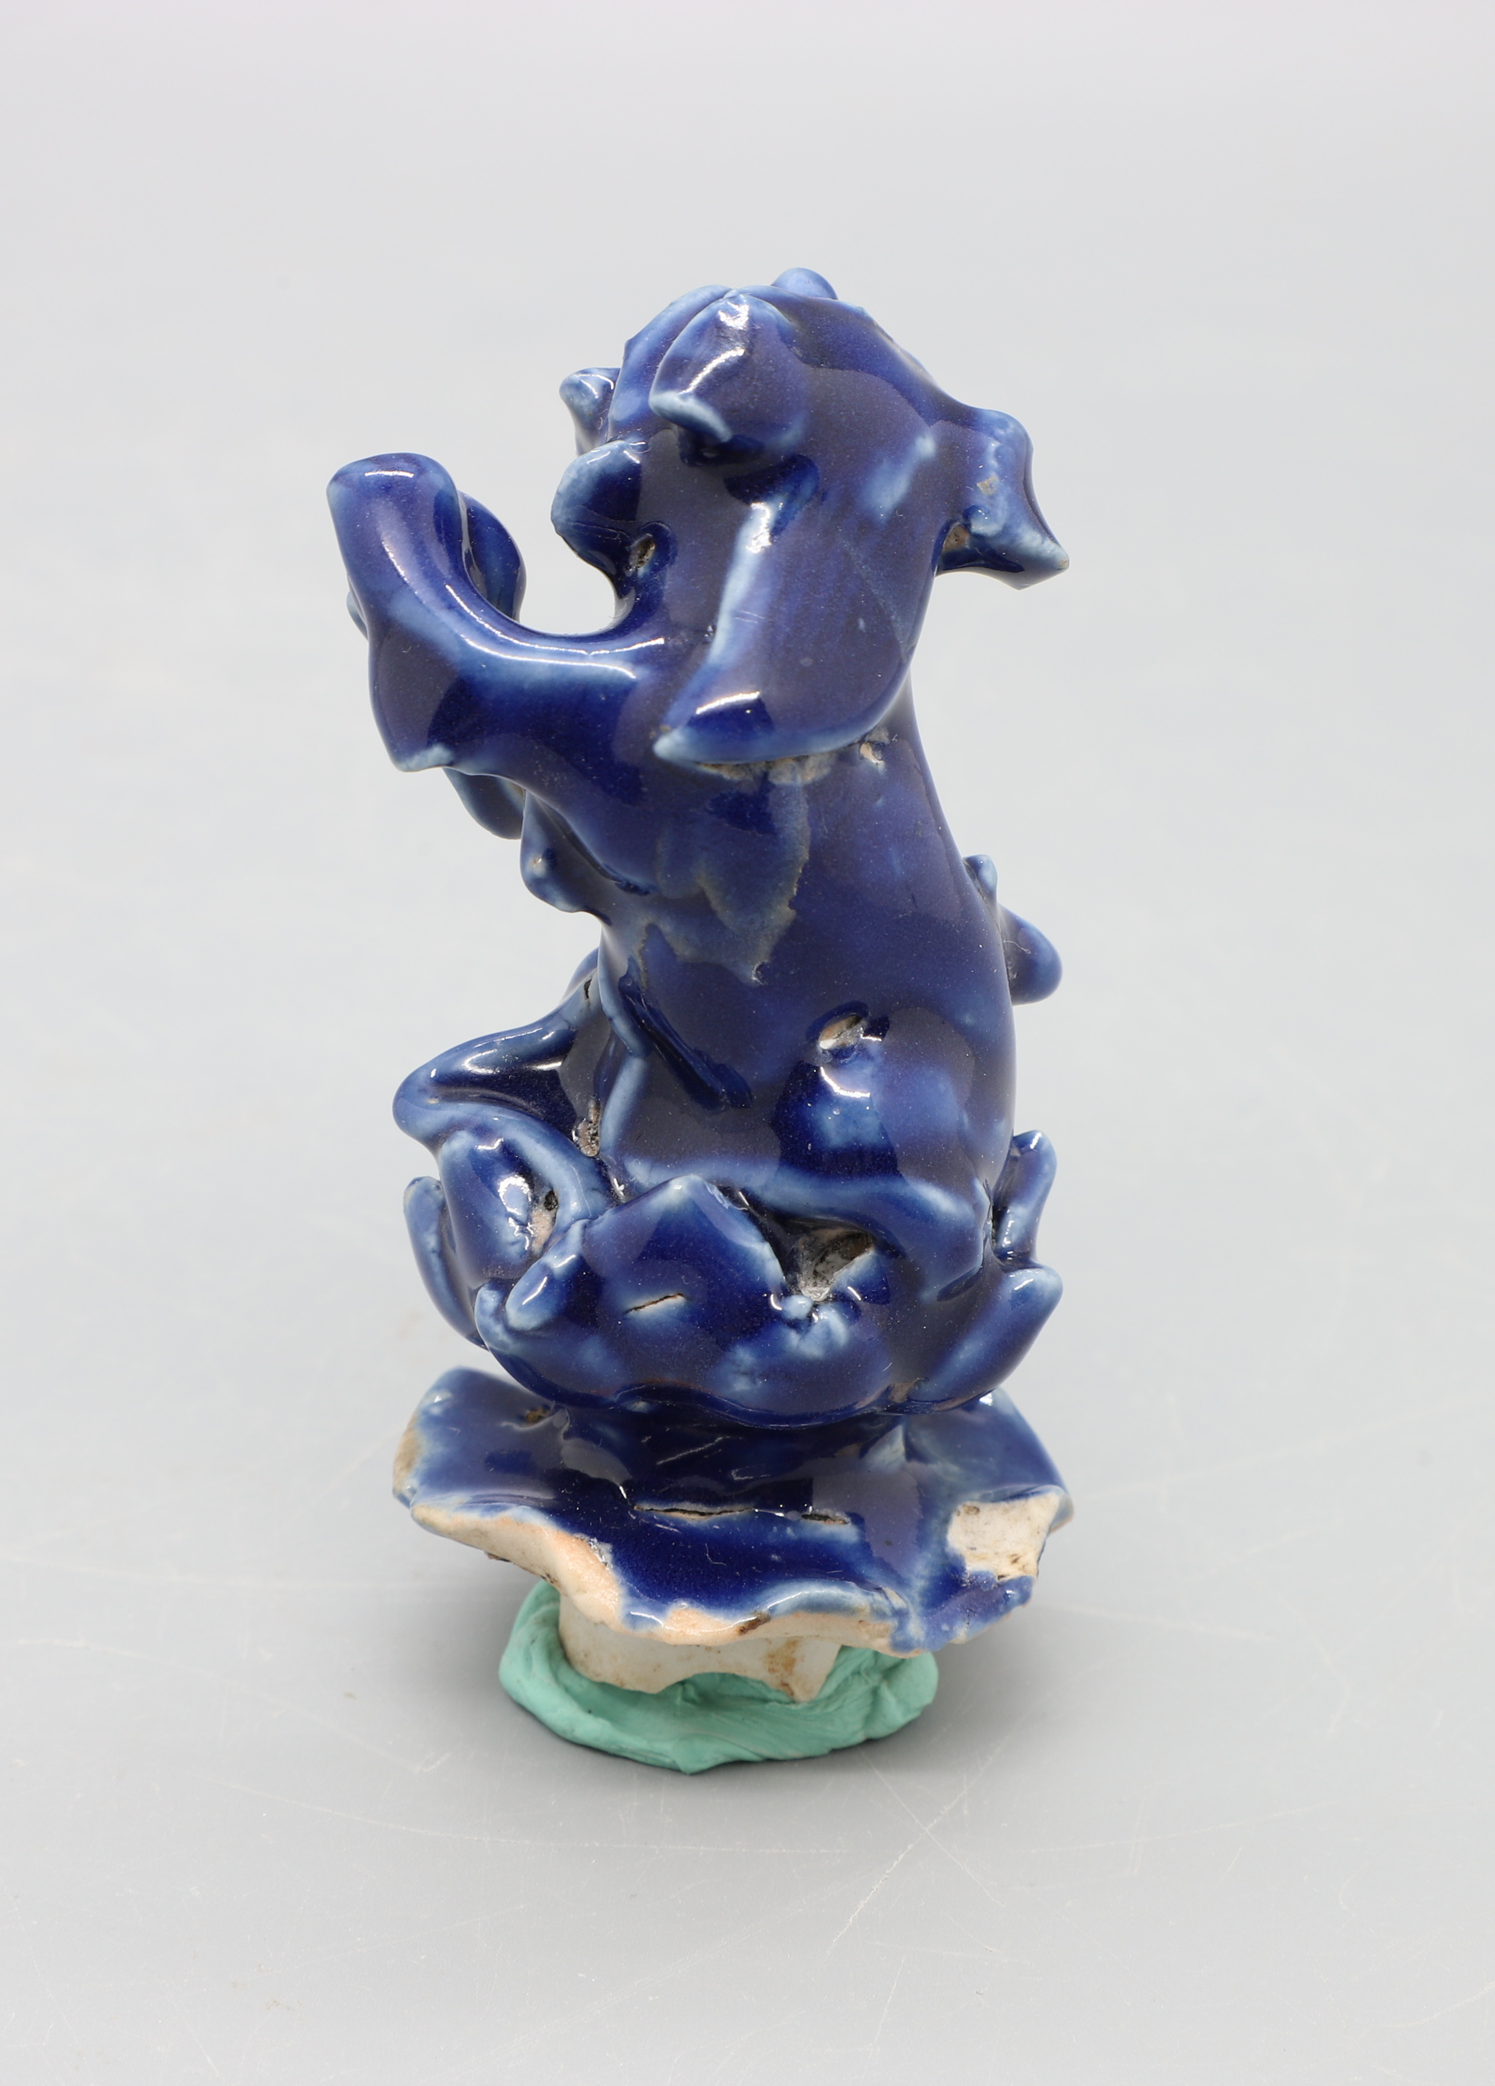
Colour Chart | 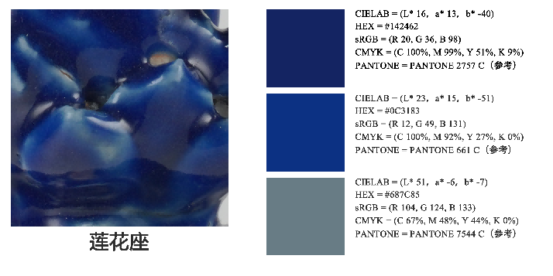
Colour Chart | 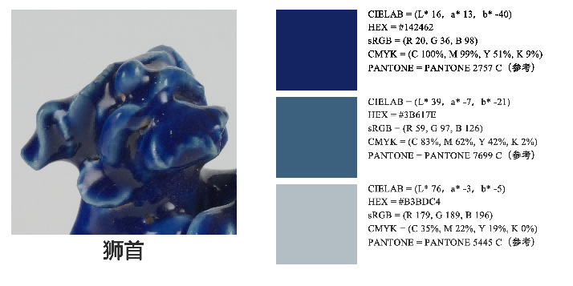
Colour Chart | 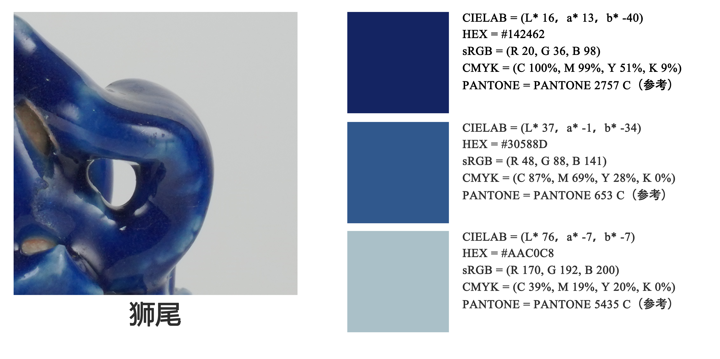
Colour Chart | 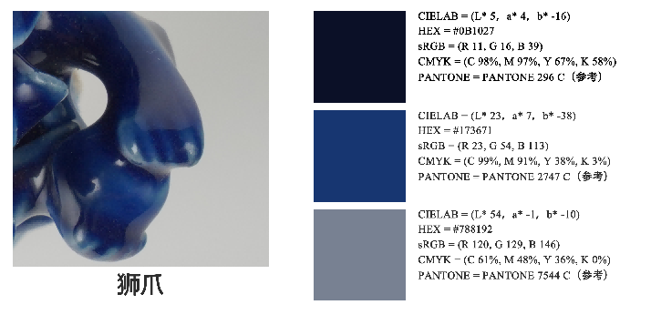
Colour Chart | 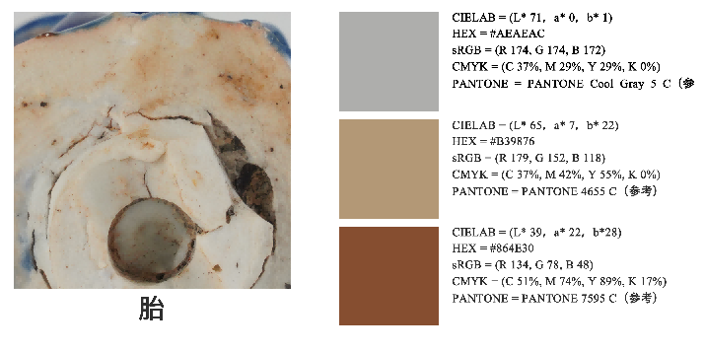
Microscopy Photos | 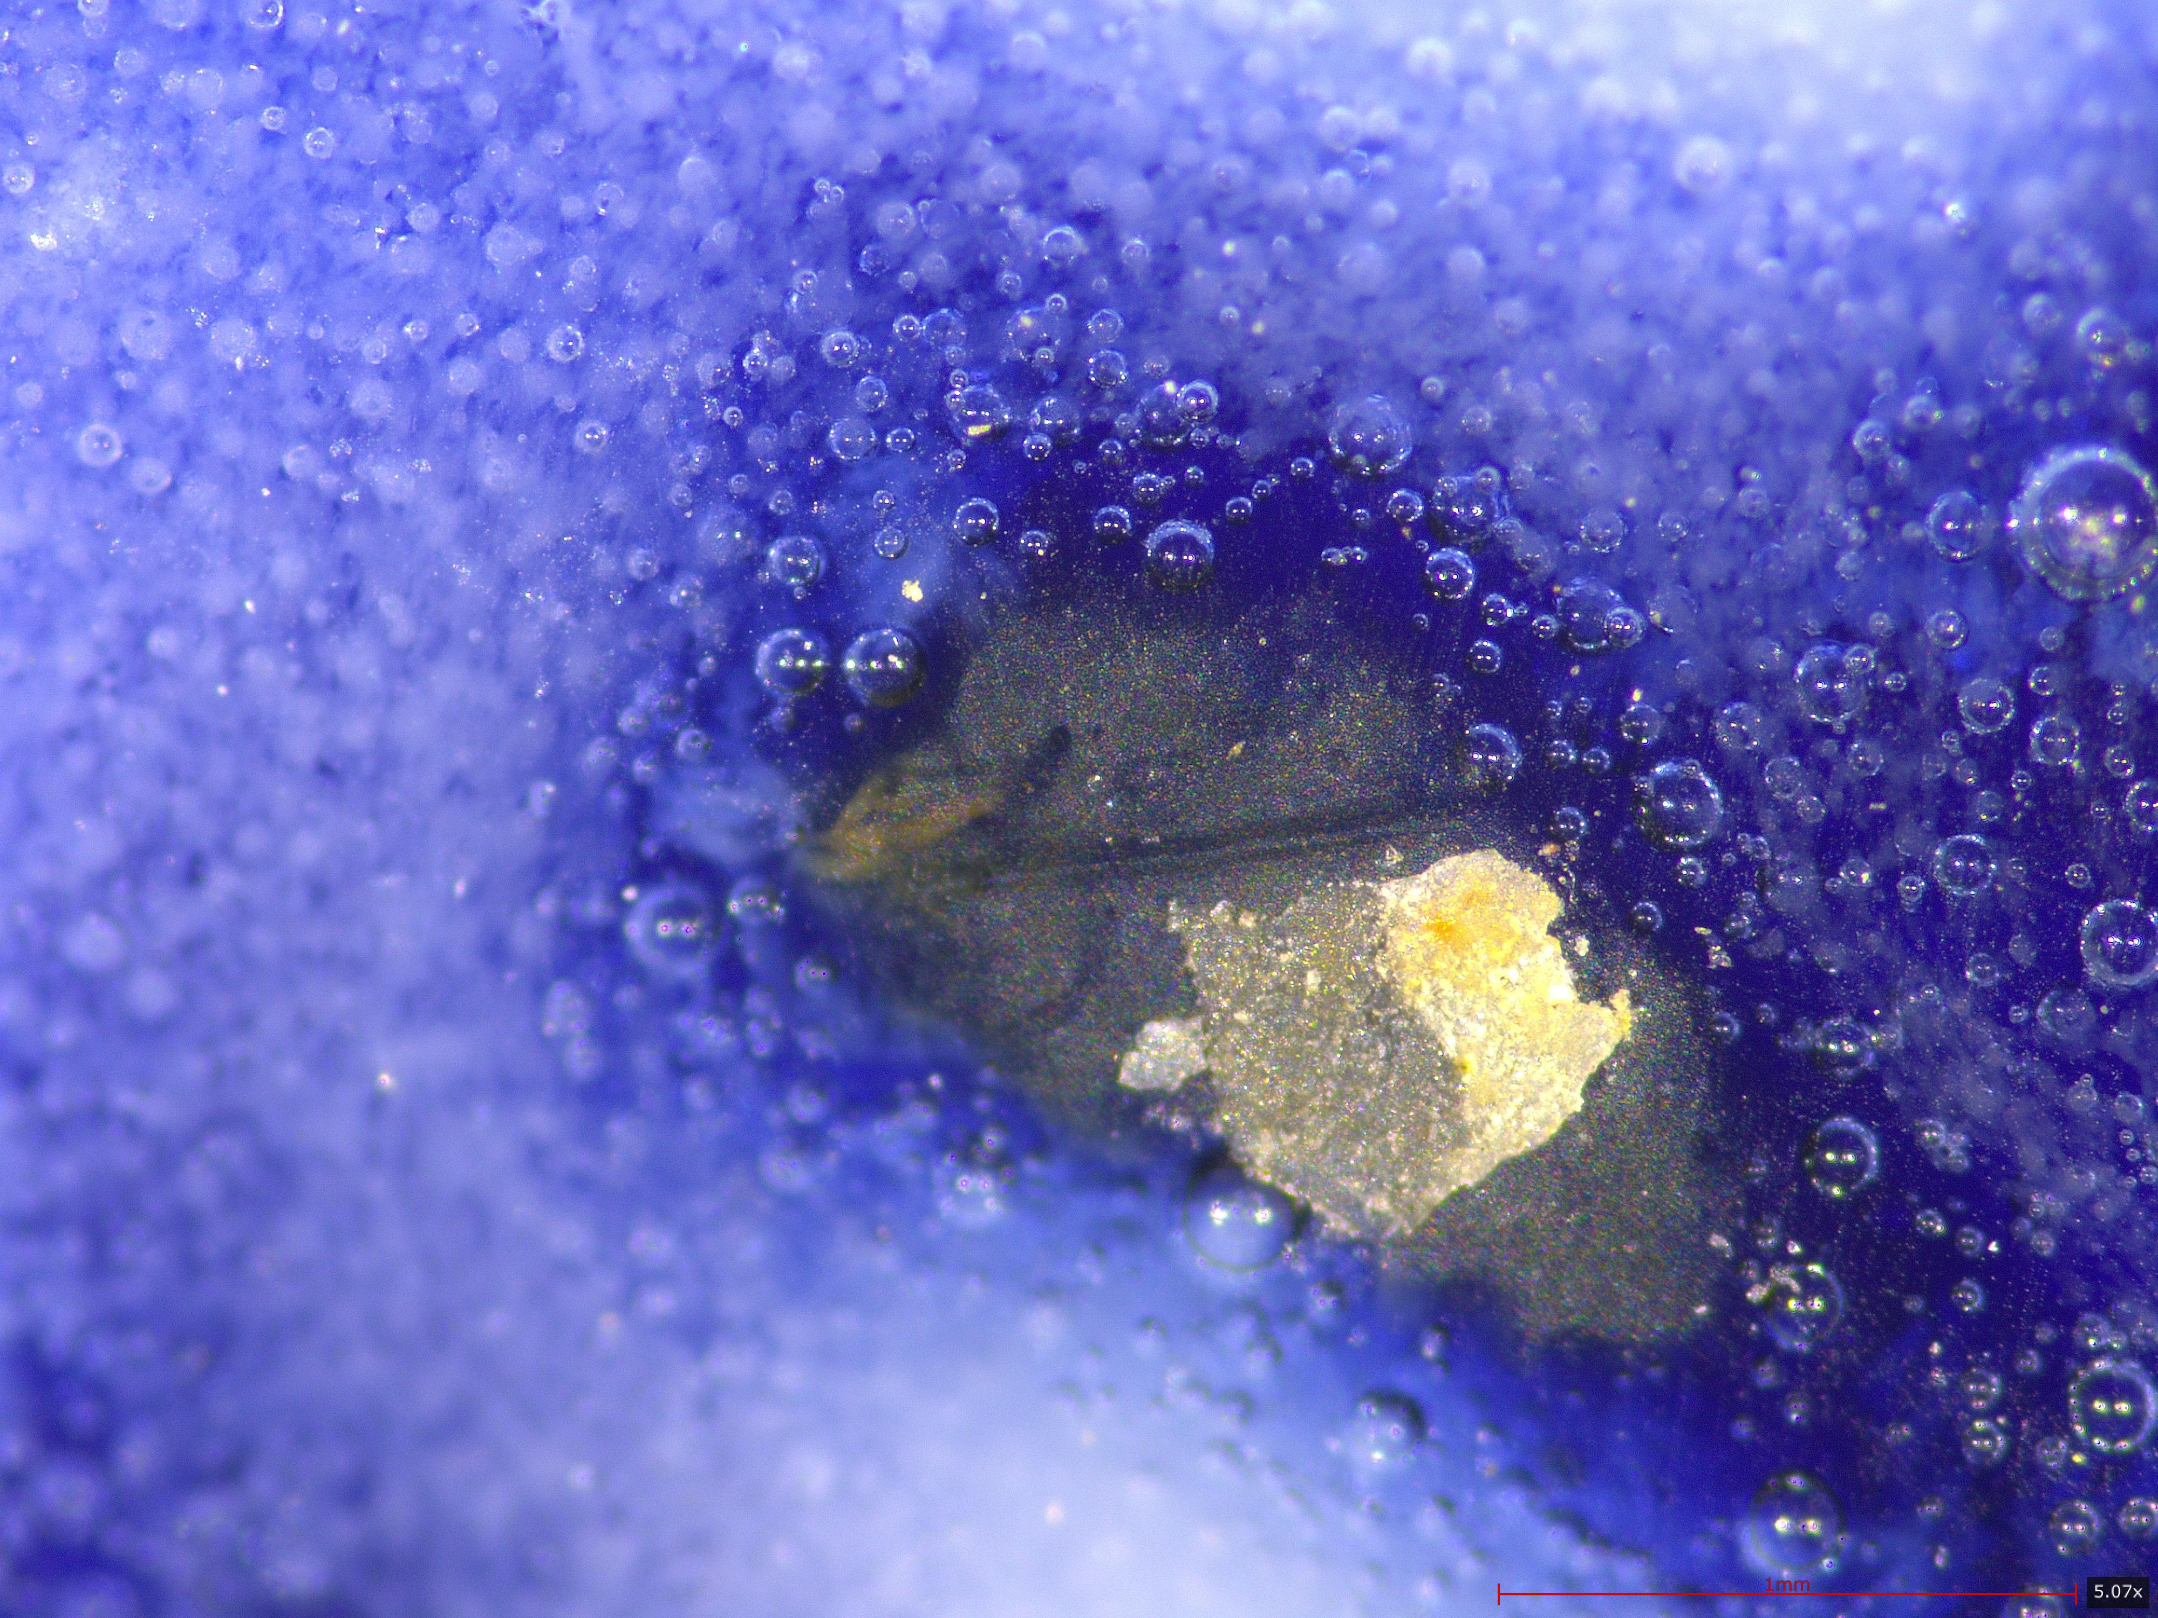 | 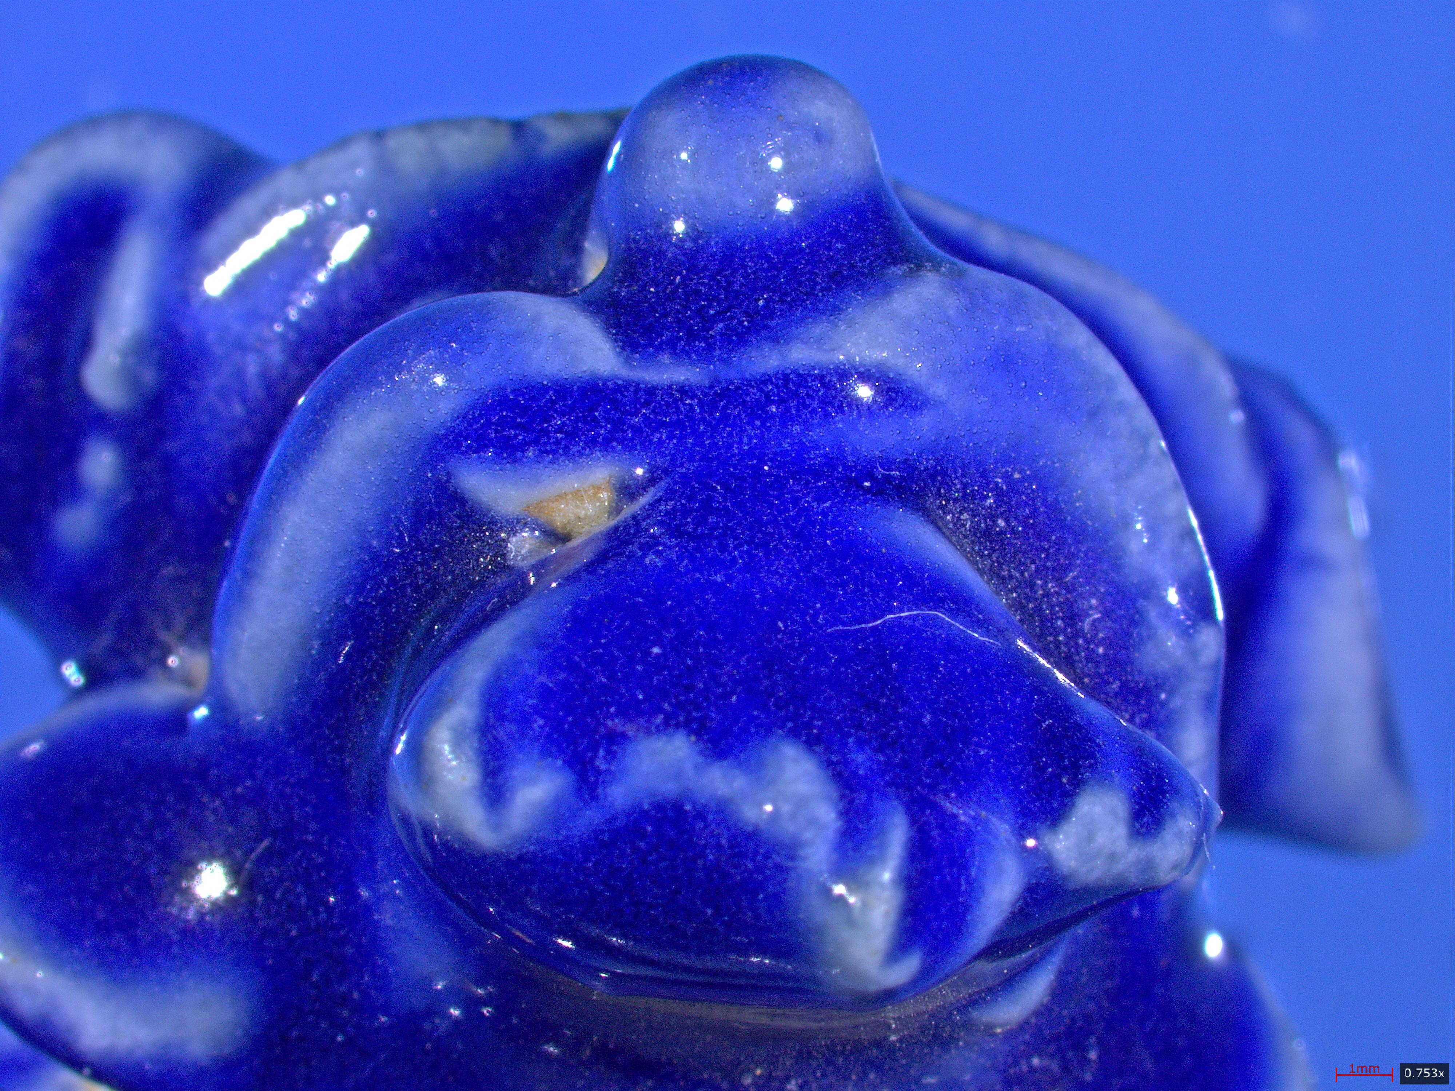 |  |  | 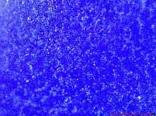
Microscopy Photos | 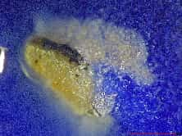 | 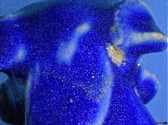 |  |  | 
References | - Weng Yanjun et al. "2024 Excavation Report of Area II — Shizi Xiang Road Site, Luomaqiao, Jingdezhen, Jiangxi." Southern Cultural Relics, 2025.  - Qin Dashu, Gao Xianping, Weng Yanjun. "Findings from the Ming-Qing Remains at Luomaqiao Kiln Site." Cultural Relics, 2020.  - Xu Xiaojiao et al. "Excavation Report of the Hongguang Porcelain Factory Site, Luomaqiao, Jingdezhen, 2023–2024." Cultural Relics, 2024.  - Huang Baiting. "Yuan-Dynasty Blue-Glazed 'Three Offerings' Vessels in the Fanchangxian Museum Collection." Identification and Appreciation of Cultural Relics, 2020.
Raman Report | 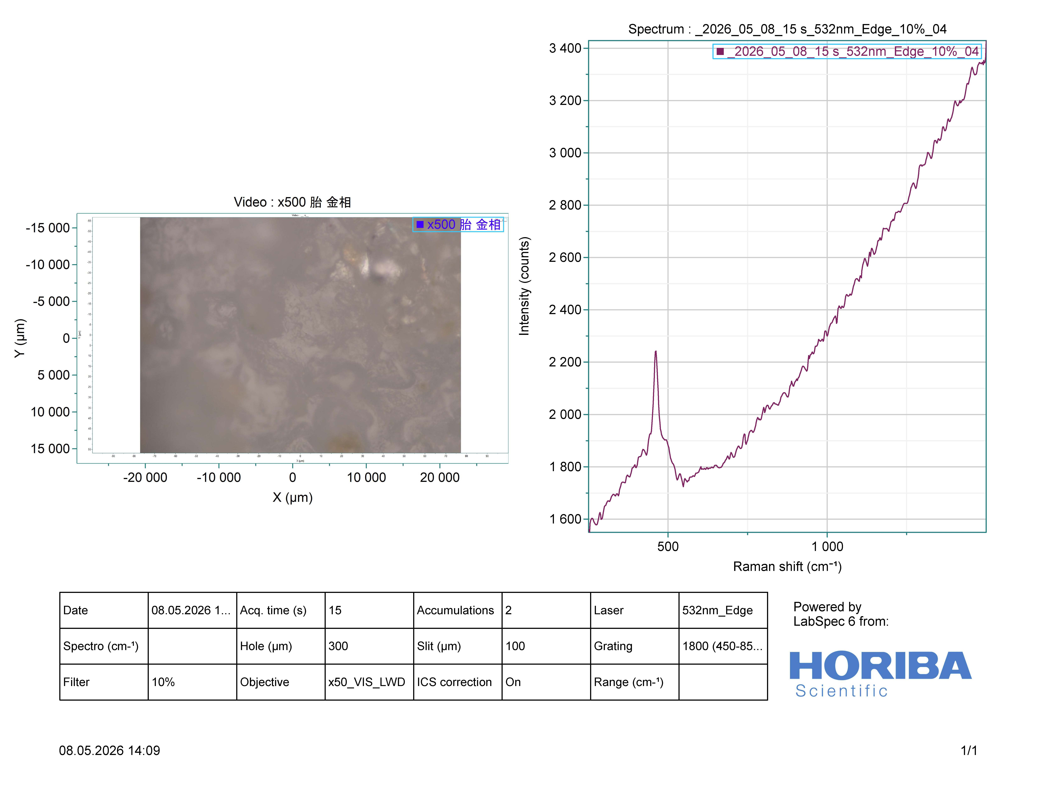  Body 500× |  |  | 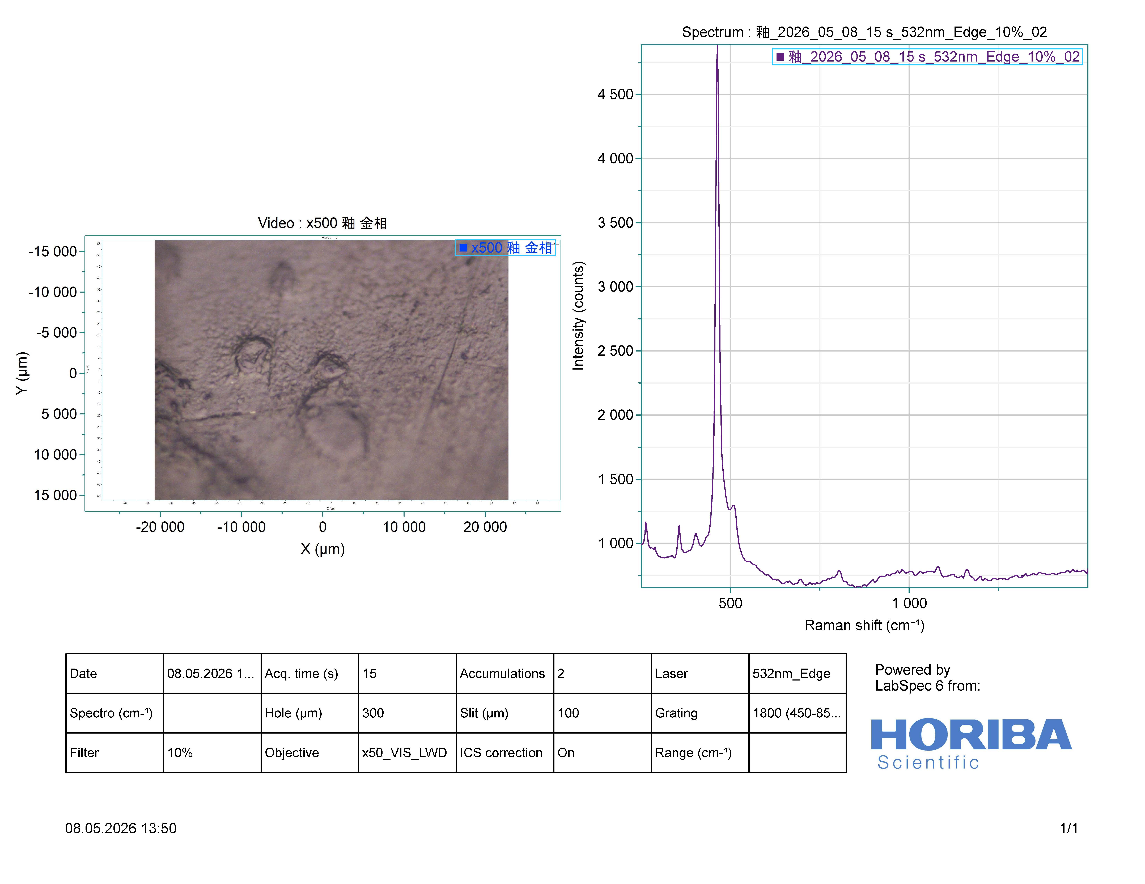Glaze 500×
XRF | 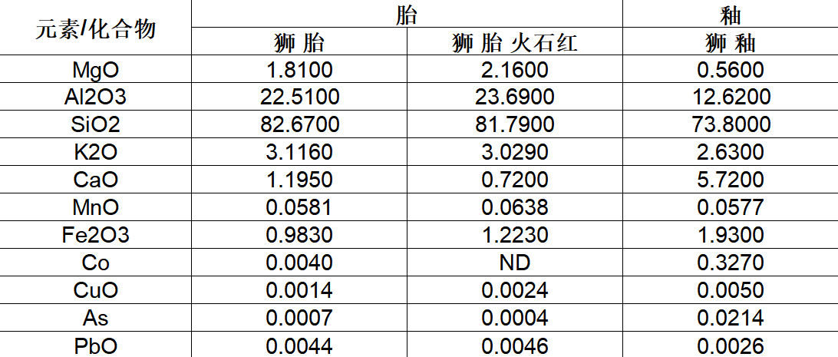
Further Design Assets | Jingdezhen Ancient Ceramics Gene Bank:  http://cgb.jdzyybwy.com:9990/lion   (mobile access)

IV. Character (for inspiration; not prescriptive)
If Ducktor Sui is all about words, Huggy Lion is all about action. It cradles its brocade ball, tilts its head at you, as if pulling you in to play. It could be a dopey guardian, a lucky charm, a hype-duck, an adventure buddy... yours to define.

V. Design Tips
• Draw boldly from the artefacts themselves — floral eyes, wing feathers, webbed feet, the pedestal, lotus base, brocade ball, sacrificial blue glaze colour — all can become your design anchors.
• The six ducks should have differentiated "duck-alities": distinct personalities, professions, identities, or era settings...
• The relationship between Huggy Lion and the Ducktor Sui family is yours to set — companions? guardians? partners? cross-species rivals?
• All names and personality descriptions above are inspirational only. Original settings are warmly welcomed.

We look forward to seeing the world you create for "Ducktor Sui and Its Friends"!

